PRESS RELEASE

Biancolilla, the unique flavours and emotions of Pantelleria
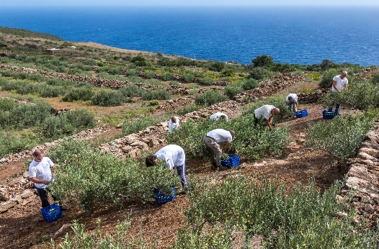
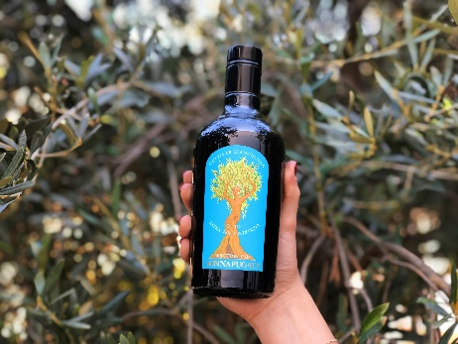
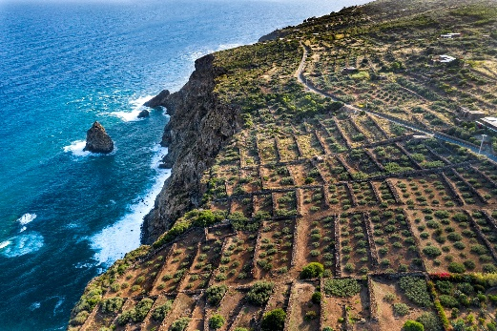
Donnafugata's Biancolilla comes into being from centuries-old creeping olive trees and heroic agriculture: a prized oil, recently awarded the 5 Gocce Bibenda, an ambassador of the flavours and landscape of Pantelleria.

Centuries-old trees just over 1 meter high, each of which can extend to a surface area of 30 square meters: these are the olive trees of Pantelleria, of the Biancolilla variety, shaped by man to remain creeping and escape the island's wind, from which Donnafugata produces an extra-virgin olive oil of great prestige.
Together with Nocellara from Etna and the Milleanni blend from Contessa Entellina, Donnafugata offers olive oil lovers the new vintage of its Biancolilla, the typical cultivar on the island of sun and wind.
Here Donnafugata cultivates just over 5 hectares of olive groves, 1,550 plants, concentrated mainly in the south-east, in the Contrada Montagnole and Dietro Isola; the use of manpower and manual labour, as for the heroic viticulture of Pantelleria, is very high.
"We started harvesting the olives in the second half of October - declares Antonio Rallo of Donnafugata - when, at the beginning of the veraison, the grapes have the maximum aromatic fragrance; more than 50 men, crouching down, hand-picked the olives during 5 days of work; in order to best extract the components of this oil, cold milling and crushing in a controlled atmosphere was fundamental. From the very low production yield of this harvest, equal to 11%, we produced only 6,500 bottles of 500 ml".
Thus a Biancolilla of particular fineness was obtained, characterized by a light fruitiness, with hints of ribbed tomatoes and aromatic herbs, such as rosemary and thyme: a delicate oil that excels on fresh salads and fish dishes.
An oil to be appreciated for its flavours and for the evocative and timeless landscape of which it is an ambassador: the terraces overlooking the sea, the dry stone walls, the twisted trunks of the older olive trees with their very wide umbrella of branches and leaves. The release of Donnafugata's Biancolilla 2019 was immediately greeted by a prestigious award, the coveted 5 Gocce Bibenda, awarded only to the best Italian oils.
"As for wine - declares Josè Rallo of Donnafugata - also for olive oil we feel like the heirs of a millenary agriculture, and we want to translate the flavours of the island into unique emotions. It is with this philosophy that we have always selected our products, trying to express the extraordinary personality of Pantelleria".
Marsala, 27 February 2020
Donnafugata Public Relations: Baldo M. Palermo baldo.palermo@donnafugata.it tel. +39 0923 724226
Laura Ellwanger pr.international@donnafugata.it tel. +39 0923 724258
Donnafugata Press Office: Nando Calaciura - calaciura@granviasc.it cell. +39 338 3229837

