PRESS RELEASE
The Contrada Marchesa Etna Rosso, noble expression of the volcano, is born
A new icon wine from Donnafugata, produced in just over 6,000 bottles from the 2017 harvest on Etna: an expression of extraordinary elegance and minerality. The protagonist of the signature label is an aristocratic volcanic goddess full of charm and mystery.
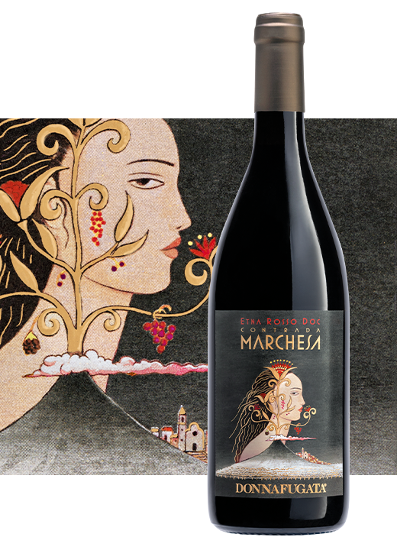
Donnafugata presents the Etna Rosso Doc produced in Contrada Marchesa, a sub-area of particular value that lies in the territory of Castiglione di Sicilia, on the northern slope of the highest active volcano in Europe.
The new prestigious cru comes from a charming vineyard of only 2 hectares, set like a precious gem in a natural amphitheatre composed of millenary lava flows.
Here, on sandy soils of volcanic origin, Nerello Mascalese is cultivated, the ancient vine that gives life to this wine produced in just over 6,000 bottles from the 2017 harvest.
Although it was a less rainy year than average, the snow that covered the vineyards in January slowly released a significant amount of water into the soil; depending on the weather conditions in the summer, the grapes were healthy and well-ripened a few days earlier and the harvest of Nerello Mascalese in Contrada Marchesa ended on October 8th.
"The vineyard in Contrada Marchesa - says Antonio Rallo winemaker of the family business - is 750 metres above sea level and is particularly sunny and windy; the vineyard is partly espalier and partly alberello, and has been so for over 80 years, producing very little, less than 1 kg per plant, albeit truly exceptional grapes. Our artisan approach - adds Antonio Rallo - focuses on the interaction between soil, microclimate and vine, and then on the expression of the organoleptic potential we have in the cellar. Thus our interpretation of all these factors has resulted in a wine that stands out for its extraordinary elegance and minerality".
Light ruby red in colour, Etna Rosso Doc Contrada Marchesa presents a fragrant bouquet of small red fruits, spicy notes and underbrush. The great balance between freshness and structure, and the fine tannic texture distinguish this cru which has made its market debut with a new signature label.
"The protagonist of the label created by our long-time illustrator Stefano Vitale is full of charm and mystery" - says José Rallo of Donnafugata - "A volcano-goddess with an aristocratic face, adorned with precious jewels: flowers and fruits that reflect the prestige of this area so well known. The label also depicts the medieval village of Castiglione di Sicilia and its vineyards covered with volcanic ash. The red of Contrada Marchesa testifies the importance we give to the small valuable productions. Today the Etna estate can count on the Sul Vulcano line in its white, rosé and red Etna Doc versions, on the Fragore Etna Rosso di Contrada Montelaguardia cru and on this new Contrada Marchesa cru. A wine - concludes José Rallo - that adds to our collection of Icona Wines, offering an exclusive and memorable tasting experience".

Marsala, 22nd of October 2020
Donnafugata Press Office: Nando Calaciura - calaciura@granviasc.it cell. 338 3229837
Donnafugata Public Relations: Baldo M. Palermo baldo.palermo@donnafugata.it tel. 0923 724226

