Press release

Rebirth: The New Donnafugata Music & Wine Album

The repertoire of jazz and Brazilian music sung by Josè Rallo appears on the main streaming platforms with the third album: Rebirth. Donnafugata celebrates the union of art and wine, to tell about Sicily through boundless, multisensory experiences.

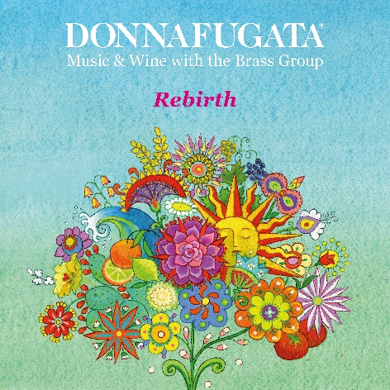
Wine and music for a unique and engaging experience, this is the principle that inspired Donnafugata Music & Wine and which returns with a new album: Rebirth, and two live concerts in Palermo, already sold-out.
On April 1st the third album of the Donnafugata Music & Wine band will be launched on the most important streaming platforms. A record which is the result of a passionate desire to share the feeling of rebirth through the dialogue between the universal language of music and wine.
"With Rebirth we offer a repertoire of 11 songs ranging from Jazz to Brazilian music with a tribute to Sicily, wine and literature" - says Josè Rallo of Donnafugata - "We liked the idea of also combining the reading of a passage taken from Il Gattopardo and a poem by Neruda with two unpbublished instrumental pieces, respectively Rose by Diego Spitaleri and Rebirth by Fabio Lannino".
Donnafugata Music & Wine is the musical project born in 2002 from an idea of José Rallo and her husband Vincenzo Favara. Josè, lead voice of the group, tells about her wines through music; in fact, each wine is paired with a piece whose rhythmic progression accompanies the sensations of tasting.

An experience that can be replicated at any time by listening to the repertoire on the new Spotify Donnafugata Music & Wine channel: from the first album, recorded in 2004, to the second album recorded in 2008 in collaboration with The Brass Group, a historic non-profit foundation in Palermo that promotes the diffusion of the culture of music.
A partnership that is renewed with the production of the 3rd album: Rebirth; the proceeds from the streaming will be donated to the Foundation for scholarships in favor of young Sicilian musicians.

PUBLIC RELATIONS Baldo M. Palermo baldo.palermo@donnafugata.it tel. +39 0923 724226 Laura Ellwanger pr.international@donnafugata.it tel+39 0923 724258

Donnfugata Music & Wine Band
The Brass Group Foundation - returns to collaborate with Donnafugata Music & Wine, thanks to some of its maestros: Diego Spitaleri (piano) and Fabio Lannino (double bass, electric bass and guitar) who also take care of the musical direction of the project, Sebastiano Alioto (drums) and Vito Giordano (flȕgelhorn). The cast is completed with the musicians Vincenzo Favara (percussion), Vincenzo Toscano (cello) and Ermanno Nuzzo (guitar).

