Press Release
Passiperduti, a new interpretation of Grillo for
Donnafugata

Donnafugata previews Passiperduti at Vinitaly, a poetic wine from the high hill vineyards of the Contessa Entellina estate. A timeless Grillo, with an elegant and floral soul, surprising for its minerality and persistence.
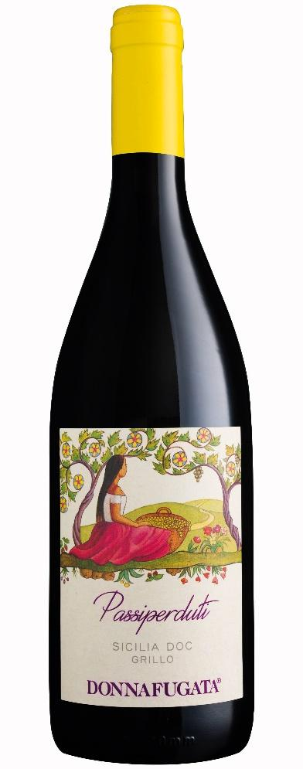
Complex and elegant, Passiperduti is the new wine made with Grillo grapes that Donnafugata is presenting at Vinitaly: a small production of value, obtained by a careful selection of grapes from Contessa Entellina Estate, in the heart of south-western Sicily.
“Passiperduti was inspired by the interactions between Grillo and the terroir of our estate,” says Antonio Rallo, winemaker of the family business. “As a result of the experience gained over many years, we have selected grapes from high hill vineyards to bring more structure, excellent minerality, and persistence into the glass”.
A new interpretation of Donnafugata for this grape variety, which joins the fresh and fruity expression of SurSur, the first pure Grillo produced by the company.
Passiperduti is the result of the 2021 harvest; after a careful selection of grapes in the vineyard and in the cellar, vinification in steel tanks emphasizes the unique personality that this grape variety is able to express in the Contessa Entellina estate.
Its wide and deep bouquet has notes of broom, citrus fruits and flint; on the palate, it has good structure and is mineral and persistent. Passiperduti is a wine of remarkable complexity and elegance, versatile in matchings: excellent with raw fish and crustaceans, vegetarian dishes and white meat.
"With Passiperduti, Donnafugata again celebrates its link with art and literature," says Josè Rallo. "A label and a name that refer to the serenity we feel when we contemplate nature, and evoke some of the most representative verses of Italian poetry: «L'infinito» by Giacomo Leopardi: Sempre caro mi fu quest'ermo colle, e questa siepe, ... Ma sedendo e mirando, interminati spazi di là da quella, . ... mi sovvien l'eterno, ... e il naufragar m'è dolce in questo mare" (This solitary hill has always been dear to me, and this hedge, ... But when I sit and gaze, I imagine, in my thoughts/Endless spaces beyond it, ... And eternity occurs to me ... And to founder in this sea is sweet to me)”.

PUBLIC RELATIONS Baldo M. Palermo baldo.palermo@donnafugata.it Tel. +39 0923 724226 Laura Ellwanger pr.international@donnafugata.it Tel. +39 0923 724258

