PRESS RELEASE
The "Khamma Trail" at Donnafugata
to discover the biodiversity of Pantelleria
A nature trail in the suggestive Pantelleria landscape
to discover the perfect harmony between nature and agriculture
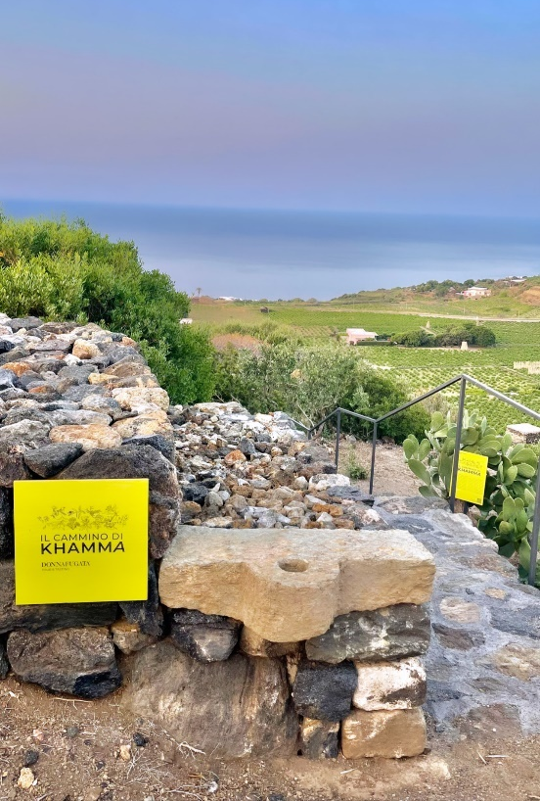
Donnafugata inaugurates the "Khamma Trail" on its Pantelleria estate, an experience designed to raise and enhance the awareness about the extraordinary biodiversity of the island that became a National Park in 2016.
The route starts from the Donnafugata winery in the Khamma district, an example of sustainable architecture perfectly integrated into the landscape.
Via a 15-minute walk on a gentle slope among terraces and drystone walls, you reach a scenic area where you can closely observe the main plants of the Mediterranean scrub of Pantelleria.
These are typical species of plants that grow in warm areas with little rainfall and that have perfectly adapted to the volcanic soils and climate of the island; over time, these plants have "colonized" the uncultivated land and they are now a characteristic of the natural landscape of Pantelleria: Euphorbia, Lentisco, Fillirea, Honeysuckle, Sicilian tea, Broom, Dafne Gnidio.
The "Khamma Trail" - conceived with the advice of the agronomist Antonella Ingianni - is enriched by texts and illustrations that guide the visitor to the discovery of the different species, reporting their scientific name, morphological characteristics, properties and traditional uses. A unique opportunity to also admire the capers and centuries-old creeping olive trees which, together with the grapevine, represent the main crops of the island and are the symbols of its sustainable and heroic agriculture.
At the end of the tour, visitors can linger in what is the Khamma Observatory and contemplate from above the perfect harmony between nature and the work of human beings, evidence of that environmental sustainability that must inspire agriculture.
The "Khamma Trail" is an experience that goes hand in hand with that of the visits and tastings offered by Donnafugata on Pantelleria, from June to September, and the visit to the Pantesco Garden donated to FAI - Fondo Ambiente Italiano, represents an example of sustainable tourism.
Pantelleria, June 2022
PUBLIC RELATIONS:

Baldo M. Palermo baldo.palermo@donnafugata.it Tel. +39 0923 724226
Laura Ellwanger pr.international@donnafugata.it Tel. +39 0923 724258

