COMUNICATO STAMPA
Prospects for the 2021 Grape Harvest at Donnafugata
The trend of the year at Contessa Entellina, Pantelleria, Vittoria and on Etna.
PRESS RELEASE
The prospects for the 2021 grape harvest at Donnafugata are good thanks to the quality-oriented agricultural practices and the favorable climatic conditions that have been recorded so far.
From the point of view of rainfall, the rainy period was concentrated in winter, particularly in February and March, while spring was dry; the vineyards are in good conditions and the delicate phases of flowering and fruit setting have taken place regularly.
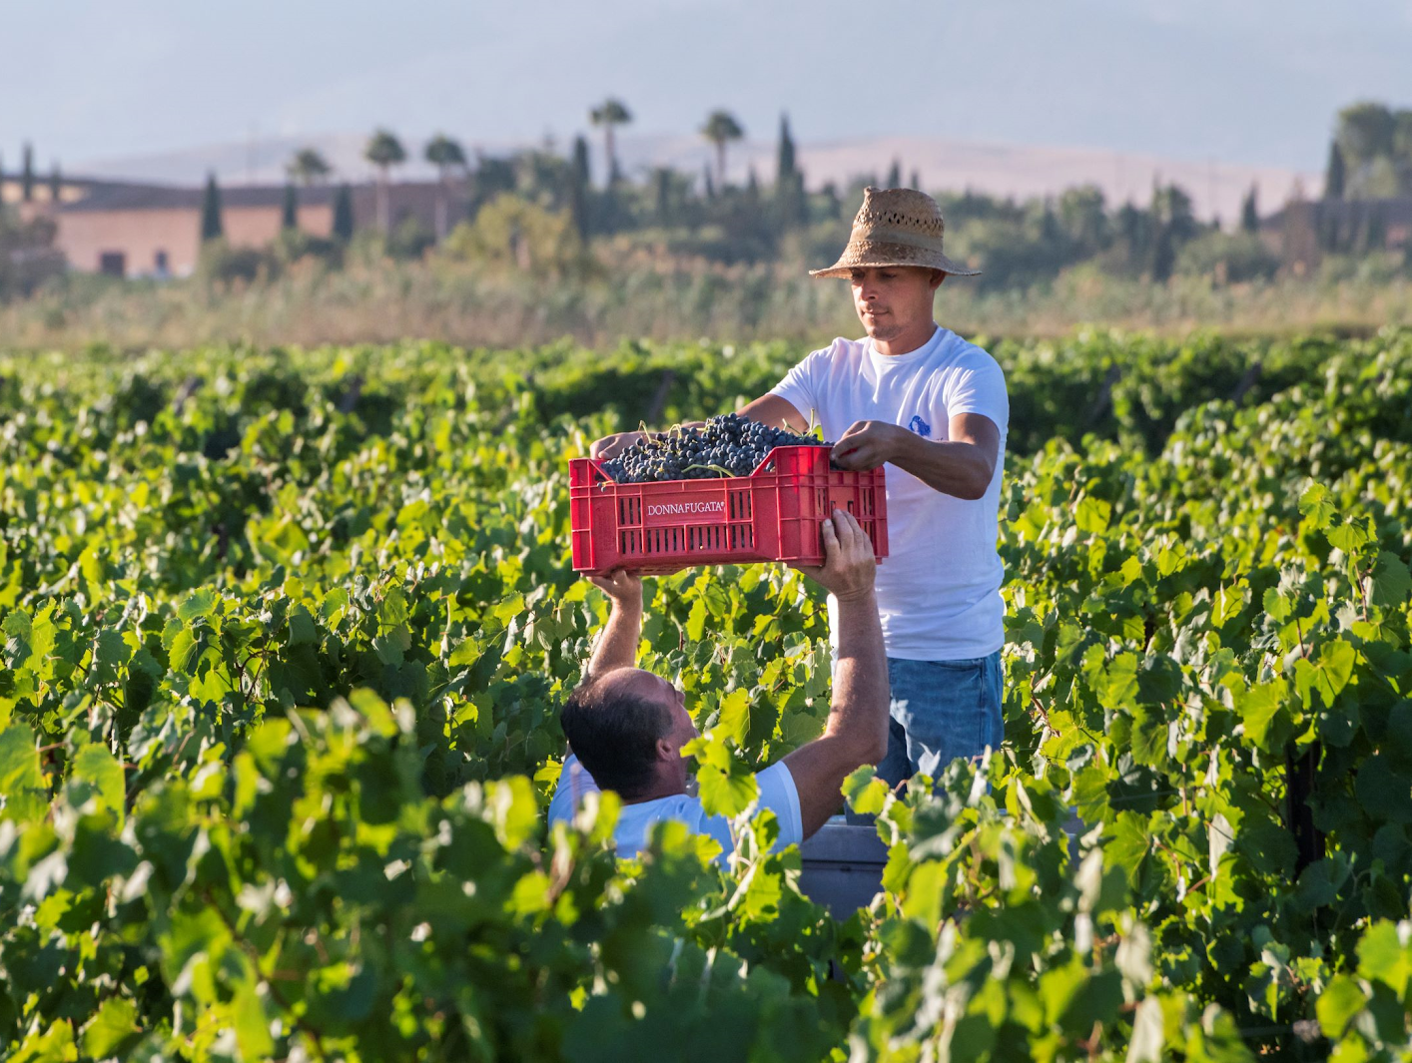
The temperatures are in line with the average of recent years: only at the end of June was there a peak of heat which slowed down the vegetative phase of the plants, then compensated for by the lower temperatures in July, which guaranteed a recovery of the normal production cycle of the plant.

"The great work we have done in the vineyard and the weather conditions we have had so far - says Antonio Rallo, agronomist and winemaker of the family business - are favoring a balanced vegetative-production cycle. We expect that the grape harvest will follow the usual periods of ripening of the different vines in the various territories. From Contessa Entellina to Etna, from August to late October, it will be a long grape harvest."

Starting at the Contessa Entellina Estate, 285 hectares in the heart of western Sicily; here, the grape harvest is expected to start during the first days of August with the grapes for the Classic Method sparkling wine base; the grape harvest will end in September.
Estimates on the quantity of grapes produced are slightly higher than in 2020 which - it must be remembered - was below the average for the territory; to date, the quality promises to be in line with the company's qualitative objectives, oriented towards prestigious productions; at this stage the production loads per plant are being defined, with some interventions of thinning carried out to favor the ideal ripening of the grapes.

On Pantelleria where Donnafugata has 68 hectares of vineyards located in 14 different districts, the grape harvest is expected to begin immediately after August 15th, in line with previous years: it will start with the grape harvest in Punta Kharace, the earliest district, and then continue, according to the ripening periods of the Zibibbo, in the different districts where they differ in altitude and exposure. The conditions experienced so far, free of adverse climatic events during the flowering and fruit setting phases, constitute a promising prospect for a production of an excellent quality.

In south-eastern Sicily, at the Vittoria Estate, in the locality of Acate, Donnafugata cultivates 36 hectares of vineyards planted with Frappato and Nero d'Avola. This is the territory of Cerasuolo of Vittoria, between the Hyblean Plateau and the sea, a prestigious and unique Sicilian DOCG (controlled and guaranteed denomination of origin). At this Estate, the trend of the vintage has generally been regular; the grape harvest should begin in early September, with quantity and quality in line with the company's objectives.

"Also on Etna, where we have 21 hectares of vineyards in the territories of Randazzo and Castiglione di Sicilia, there are good prospects for an excellent vintage" - says Antonio Rallo. "The conditional is a must if we consider that the start of the grape harvest is still two months away, but there is reason for hopeful thinking. We completed the green pruning and, if necessary, we will do some thinning so that the production load of the plants is in line with our quality objectives and that grapes arrive at harvest time healthy and quite."
Marsala, July 21st, 2021
PRESS OFFICE Nando Calaciura calaciura@granviasc.it cell. 338 3229837
PUBLIC RELATIONS Baldo M. Palermo baldo.palermo@donnafugata.it tel. 0923 724226

