PRESS RELEASE
With Fragore on Etna: the Donnafugata icon wine.
The new cru produced in Randazzo, in contrada Montelaguardia,
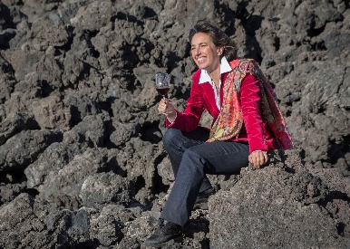
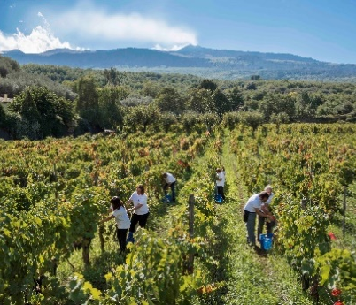
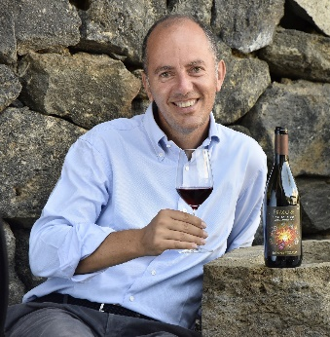
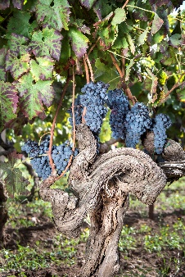
is an icon wine to join Mille e una Notte from Contessa Entellina and Ben Ryé from Pantelleria. In wine shops and restaurants in November. Only 15 thousand bottles produced.

For once, the Fragore of Etna is not the roar that accompanies new eruptions, those that for millenia flow from the Europe's highest and most active volcano, but it's the name of a wine. The Fragore that erupts onto the scene is the latest red born at Donnafugata, that in the 2016 harvest selected the best parcels of Nerello Mascalese to propose a cru of excellence.
The declared objective is to produce an icon wine of Etna where Donnafugata arrived to express its extraordinary potential. Exactly how it happened in other prestigious winegrowing areas in Sicily: with Mille e Una Notte in Contessa Entellina and Ben Ryé on Pantelleria. A meticulous commitment that, this time, has involved the north slopes of the volcano, in Randazzo, in Contrada Montelaguardia, a sub-zone whose uniqueness is recognized by the specific mention on the label, together with DOC Etna.
The Donnafugata vineyards in Montelaguardia, just over 4 hectares, are located at 750 meters above sea level, east of the town. In this district the composition of the terrain is the fruit of the lava flows of the sixteenth and seventeenth century; the interaction between these terrains, their microclimate and the vineyards, even 70 years old and older, make the characteristics of the grapes produced here and of the resulting wine unrepeatable and exceptional.
A terroir of particular charm with favorable pedo-climatic conditions: on one side “a Muntagna”, on the other the Nebrodi Mountains that partially act as a barrier against the currents of air heralding rain from the north; in Randazzo a sort of “climatic pocket” is created, characterized by lower rainfall than the other sides of the volcano.
The area where Fragore is born therefore enjoys the advantages of the altitude characterized by a wide variation between night and day temperatures, especially in summer. These are the premises that favor the production of grapes of great aromatic finesse. And, moreover, the not excessive rainfall, the high draining capacity of Etna's sandy soils and the frequent Tramontana winds, offer the best conditions in order to have healthy and perfectly ripe grapes.
“In 2016 we harvested the Montelaguardia Nerello Mascalese in just a few days – says Antonio Rallo of Donnafugata –; the grapes we vinified in our Randazzo winery were beautiful, rich in mature polyphenols that have given us high quality structure”. And in fact Fragore is a wine that has an ample and deep bouquet, of elegance and volcanic personality; the fruity notes are very clear, also the flowery, spicy and balsamic notes, on the palate, integrated and supported by notable tannins and remarkable persistence. “In few other regions of the world – Antonio Rallo concludes – you can achieve such complexity, able to evolve over time.”
The expression of Fragore recalls Donnafugata's imagery and the force of nature that creates and transforms. “We have always been projected towards the future – says José Rallo of Donnafugata – ever since our parents Giacomo and Gabriella founded the family winery. And the label of Fragore – that we also wanted to communicate through a splendid video animation – is a metaphor of our commitment that led us from western Sicily to the east, to Vittoria and Etna; the illustrator, Stefano Vitale, captures this perpetual motion like that of an object in space, attracted by invisible gravities, and returns it with the appearance of a flaming woman, whose roar announces the energy of the volcano. A unique label, like the soul of this wine.”
Just over 15,000 bottles of Fragore 2016 Etna Rosso DOC Contrada Montelaguardia have been produced; available for restaurants and wine shops from early November.
Marsala, 25 October 2018
PUBLIC RELATIONS Baldo M. Palermo baldo.palermo@donnafugata.it / Laura Ellwanger pr.international@donnafugata.it
PRESS OFFICE Nando Calaciura calaciura@granviasc.it
Public Relations: Baldo M. Palermo baldo.palermo@donnafugata.it tel. 0923 724226

