PRESS RELEASE
Gabriella Anca Rallo, Commendatore della Repubblica.
A recognition of her contribution to the promotion of the role of women and the development of the quality and image of winegrowing on the island.
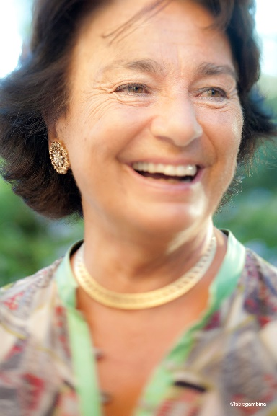
Gabriella Anca Rallo has been conferred the title of Commendatore della Repubblica Italiana; the high honor has been awarded to Madam “Donnafugata” for her merits in favor of the affirmation of Sicilian wine and the promotion of the woman's role in the island.
An exemplary human and professional story – that of Gabriella – : for the determination and success with which she has pursued her objectives, facing the difficulties of life and the challenges of work.
After the sudden death of her father, she finds herself at the helm of the Contessa Entellina estate. It is the ’70s, in the territories where the Belìce earthquake had sown destruction; here, with courage and obstinacy, she starts a slow but inexorable shift towards quality.
She who, after her classical studies in Florence, the Diploma in Translation obtained in Geneva and the degree in Political Science, had become a teacher of the English language and literature at the Lyceum, within a few years, left the school to devote herself completely to viticulture.
Together with her husband Giacomo Rallo, Gabriella shares the vision of a new Sicily of wine, and in order to realize their dream they create Donnafugata, as she wanted their company to be called, with the logo that features a woman's head with windblown hair.
A name that is not only evocative of the Leopard and the Belìce hills that Tomasi di Lampedusa was inspired by, but that soon reveals itself as an identifying manifesto: Donnafugata is a winery in fuga (in flight), in perpetual motion towards ever new and more advanced goals.
Gabriella travels far and wide, from France to California and draws inspiration for an original and innovative interpretation of the Sicilian winegrowing potential. She summons the best consultants, reduces yields per hectare, enhances the autochthonous vine varieties and, at the same time, experiments international varieties. For these reasons Gabriella is considered a pioneer and a protagonist of the renaissance of Sicilian wine.
Her role in the sphere of communication has also been decisive. The identifying force that Gabriella wanted to impress on the company is expressed above all through the labels that have contributed to making Sicily famous throughout the world: the illustrations they originate from have extraordinary personality, true works of art created or inspired by Gabriella who has succeeded in making use of the artistic collaboration of Stefano Vitale, thus succeeding in making every bottle of Donnafugata the icon of a symbolic universe of exceptional imaginative strength.
Labels that are revolutionary and very successful because in them Gabriella wanted to carry the colors of the sun, the sea and her land. The names such as Tancredi, Floramundi, Mille e una Notte or Fragore, Donnafugata's latest wine produced on Etna, are also very evocative.
Since Giacomo Rallo's death in 2016, Gabriella and her children José and Antonio have maintained the values and the vision. From western Sicily, with the Contessa Entellina and Pantelleria wineries, to eastern Sicily, on Etna and in Vittoria, Donnafugata expresses the great potential of the island's best winegrowing territories, focusing on valuable productions that are exported to over 60 countries.
At this time, she has received many congratulatory messages from people who, having met her, appreciate her radiance, fantasy, contagious congeniality and natural elegance.
The honor of Commendatore bestowed by decree of the President of the Republic, on proposal of the Presidency of the Council of Ministers, was awarded to Gabriella Anca Rallo by Prefect of Trapani Darco Pellos as part of the National Unity and Armed Forces Day celebrations. The ceremony took place Sunday 4 November in Trapani.
Marsala 4 November 2018
PRESS OFFICE Nando Calaciura calaciura@granviasc.it cell. 338 3229837
PUBLIC RELATIONS Baldo M. Palermo baldo.palermo@donnafugata.it tel. 0923 724226

