PRESS RELEASE
Donnafugata for Dolce&Gabbana
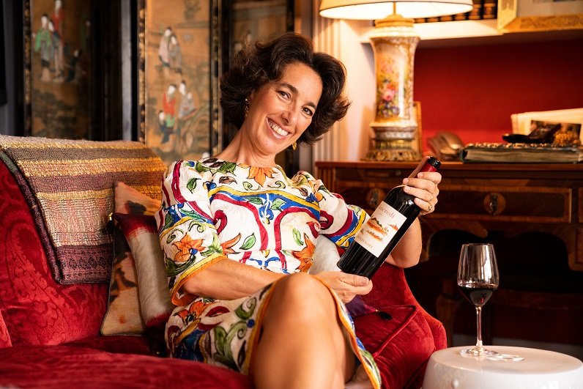
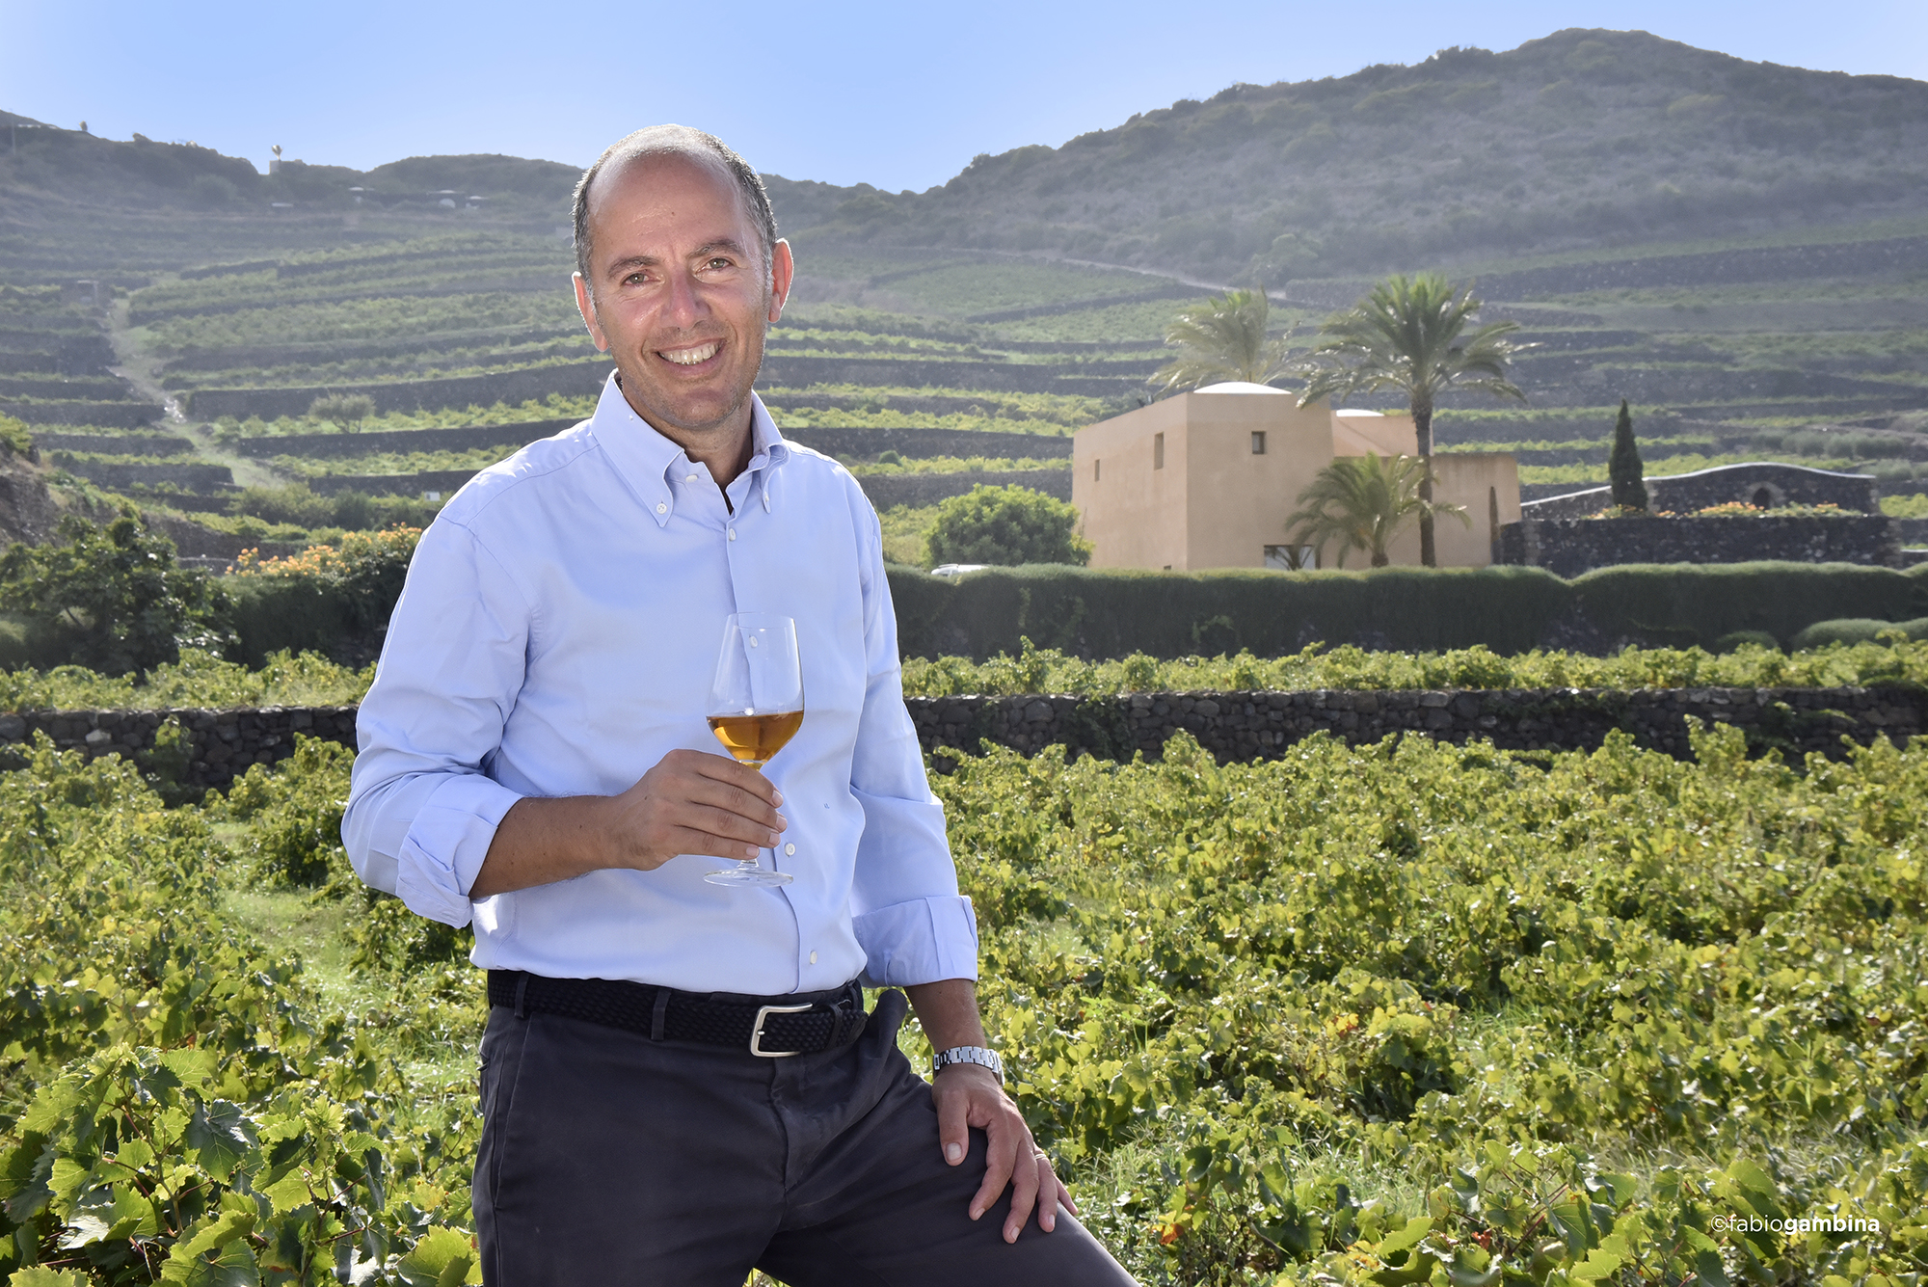
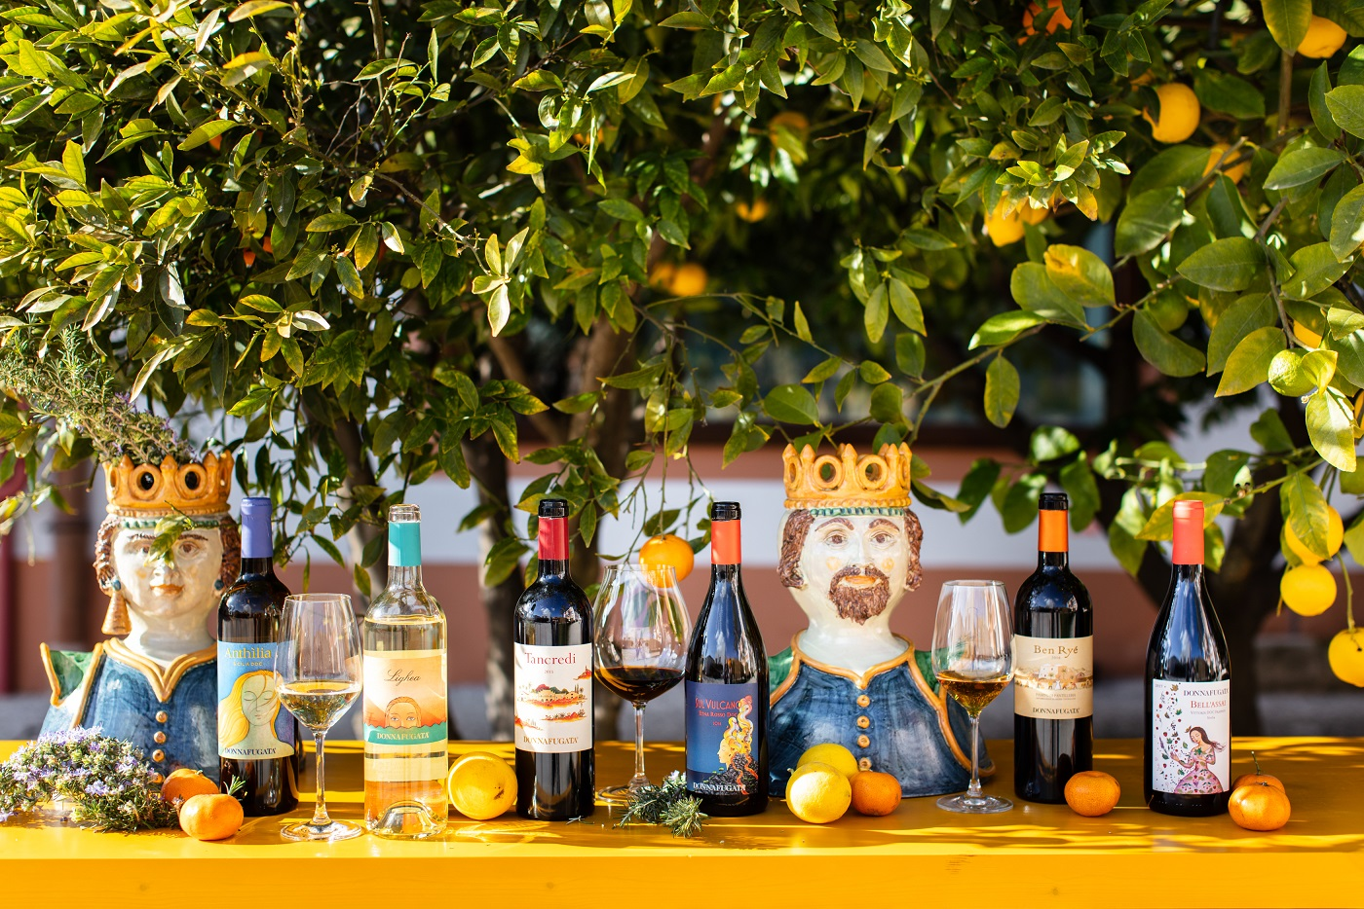
Dolce&Gabbana returns to Sicily in July and chooses Donnafugata for the events that will be held in Agrigento: an encounter between excellences of Made in Italy that take Sicily into the world.

As in 2017 in Palermo, Donnafugata wines will be chosen once more by Dolce&Gabbana for the celebrative moments of the events Alta Moda, Alta Sartoria, Alta Gioielleria of 2019, that the Italian fashion house dedicates every year to its special creations.
Two years after the big appointment that lit up the capital, Domenico Dolce and Stefano Gabbana return to celebrate Sicily, their inspirational muse, choosing to make a stop in Agrigento, with the Valley of the Temples and its territory rich in history: from Palma di Montechiaro, crucial for Tomasi di Lampedusa in the writing of The Leopard, to Sciacca with its historic center overlooking the sea.
Dolce&Gabbana blends sartorial excellence, art and culture, projecting Sicily into an elegant and refined dimension: the same one that Donnafugata is an expression of, to leave its international guests an unforgettable memory of the island's wines.
From 4 to 7 July, over 400 guests and journalists will experience the emotions of an open-air catwalk in some of the most iconic places in Sicily.
All the events will be accompanied by the best Donnafugata labels, thus celebrating an encounter between excellences of Made in Italy that take Sicily into the world: the western one with the wines from Contessa Entellina and Pantelleria, and the eastern one with the wines from Vittoria and Etna.
“Our wines are the fruit of precious small productions, from unique territories and vineyards – says Antonio Rallo winemaker of the family winery –. The attention to detail and love for Sicily that we put into our work are the same that give rise to Dolce&Gabbana's extraordinary creations; for this we were very happy about the invitation and to be with them again.”
“With Dolce&Gabbana – explains José Rallo, head of communication of Donnafugata – we share a sunny vision of Sicily, where the colors, themes of nature and our culture, are reproposed and evoked in an ever new key: it is the fantastic and feminine imagery that is present on our artistic labels, unique works capable of making the personality of each wine shine, in dialogue with art.”
The Donnafugata wines in tasting will suggest the mosaic of a Sicilian viticulture rich in diversity and style: from the Grillo SurSur to the Chardonnay Chiarandà from Contessa Entellina, from the Nerello Mascalese from Etna, Sul Vulcano, to the Cerasuolo di Vittoria Floramundi, and the Zibibbo that Ben Ryé Passito di Pantelleria is produced from.
Marsala, 4 July 2019

Public Relations: Baldo M. Palermo baldo.palermo@donnafugata.it tel. +39 0923 724226
Laura Ellwanger pr.international@donnafugata.it tel.+39 0923 724258

Press Office: Nando Calaciura calaciura@granviasc.it cell. +39 38 3229837

