Press Release

Calici di Stelle 2019 at Donnafugata
Wine and Art of the Sicilian Puppets

A special San Lorenzo night for winelovers and Donnafugata enthusiasts. On August 10, in the estate of Contessa Entellina, the character of the Donnafugata wines will be combined with the personality of the protagonists of the Sicilian Puppet Opera, a UNESCO World Heritage. Interpreting the Wine and Art dialogue is the historic puppet company of the Fratelli Napoli of Catania. Not to be missed is the visit to the vineyards and winery and the grand tasting with over 20 labels to sample, including some precious vintages of iconic wines.
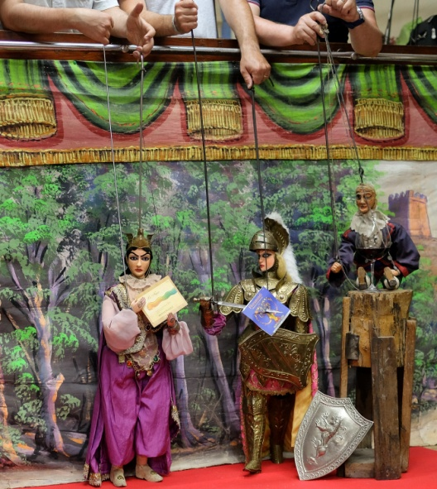
On the night of Saturday, August 10, Donnafugata will celebrate, in the family estate, a Calici di Stelle full of charm and poetry in Contessa Entellina. The Sicilian company, with this 22nd edition of the most important event of the Wine Tourism Movement, continues its dialogue with art.
After the dance between the vines, the live percussions in the heart of the Sicilian night and the audiovisual performance of the Invisible Orchestras on the nocturnal harvest, Calici di Stelle 2019 will be the scene of a new contamination of Wine with Art, this time that of the Sicilian Puppet Opera and its original iconography.
"It's a world we feel close to because some of our wines recall the tradition of Puppet Opera in their iconography or in the name they bear, such as Angheli, Tancredi, Floramundi, - explains José Rallo, owner of Donnafugata together with his brother Antonio - What we have in common are the values, the craftsmanship, the colours and the extraordinarily distinctive and imaginative language. Donnafugata would like to pay homage to a very refined folk art, a UNESCO Intangible Heritage of Humanity, which offers infinite fascination and which can combine culture and wine with the traditions of a community".
It will be the marionette company of the Fratelli Napoli – a legend of the Sicilian Puppet Opera to the fourth generation - to interpret this time the dialogue between art and wine.
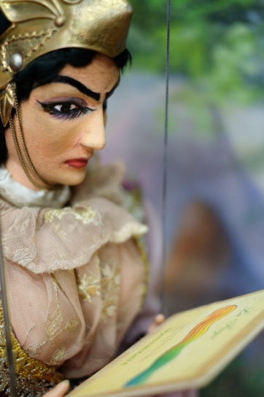
On August 10 the winelovers will toast to the moonlight, following the exploits of the beautiful Princess Angelica in combination with the notes of Chardonnay La Fuga and those of the brave paladin Bradamante on the floral and spicy scents of red Floramundi, Cerasuolo of Vittoria.
The occasion of the collaboration with the Fratelli Napoli brought Donnafugata into contact with the Antonio Pasqualino International Museum of Marionettes in Palermo, which houses part of their collection. The desire to contribute to the maintenance of the tradition of the Puppet Opera House, through the use of the ART BONUS application, arose spontaneously. Donnafugata will finance a project for the restoration of two historical puppets in the collection: Angelica and Carinda, precious pieces and in need of intervention on which the museum association has prepared detailed restoration records. A choice of responsibility and promotion of the territory, in line with the values that have always guided the company.
The Programme and the tastings
The night of San Lorenzo at the Contessa Entellina estate (Km 60 of the S.S. 624) will begin at 21, with a welcome toast dedicated to the rosé Sul Vulcano Etna Doc, a wine with refined minerality and the latest addition to Donnafugata.
Then in the vineyard, the exhibition of the Sicilian marionettes of the Fratelli Napoli in combination with Donnafugata's wines. Two representations, two wines. The story of Angelica, an exotic fleeing princess, will be accompanied by a tasting of La Fuga Chardonnay. Bradamante, an unusual amazon with a fruity pink mantle, will battle on the notes of Floramundi, Cerasuolo di Vittoria.
A stroll to the vineyard by moonlight and then to the winemaking cellar to get to know some aspects of the production of quality wine is a must.
The night of Goblets of Stars will continue in the charming garden of Donnafugata, where all the wines produced by the company in its different estates can be tasted: Contessa Entellina, the company's historical terroir in western Sicily; Pantelleria, an island of a volcanic nature and heroic viticulture; Etna, on the northern side of the highest active volcano in Europe; Vittoria, with the only DOCG in Sicily. A kaleidoscope of terroirs, vines and oenological interpretations in pure Donnafugata style.
There will be more than 20 labels for tasting, including the iconic wines: the red Mille e Una Notte and the Passito di Pantelleria Ben Ryè, to which will be added a special selection of historic vintages, no longer on the market.
A special focus will be dedicated to the DOC reds produced on Etna: the iconic wine Fragore, cru of Contrada Montelaguardia and Sul Vulcano, both expressions of the native variety Nerello Mascalese. It will be an opportunity to learn about the new welcome project in the winery of Randazzo where visitors can explore the vineyards of the company, visit the barrique cellar, deepen their knowledge of the wines of the area and experiment with refined wine and food pairings.
Following the tradition, in the olive grove, at the end of the tasting, there will be live music by the Fancies, a band from Palermo, the capital of the region, which, amongst Italian-made songwriters, Chicago Blues, 1960s British Invasion rock and retro electronics, will animate another memorable edition of Calici di Stelle in Donnafugata.

Marsala, 26 July 2019

Calici di Stelle: 10 August 2019, from 21:00 to 01:00;
Donnafugata estate, km 60 Strada Statale 624 Palermo-Sciacca expressway
INFO: https://visit.donnafugata.it/it/eventi/contessa-entellina/calici-di-stelle-2019-2
Ticket: online pre-sale, subject to availability, 25 euros plus 5 euros deposit for the glass;
possibility to buy on site at € 35 + € 5 glass deposit
free ticket for children under 18 years of age.
Finally, a fundamental logistical note: the Donnafugata estate is located exactly at kilometre 60 of the 624 Strada Statale along the Palermo-Sciacca expressway.

PUBLIC RELATIONS Baldo M. Palermo baldo.palermo@donnafugata.it tel. +39 0923 724226
Laura Ellwanger pr.international@donnafugata.it tel. + 39 0923 724258

PRESS OFFICE Nando Calaciura calaciura@granviasc.it cell. +39 338 3229837

