PRESS RELEASE
Calici di Stelle 2019 at Donnafugata
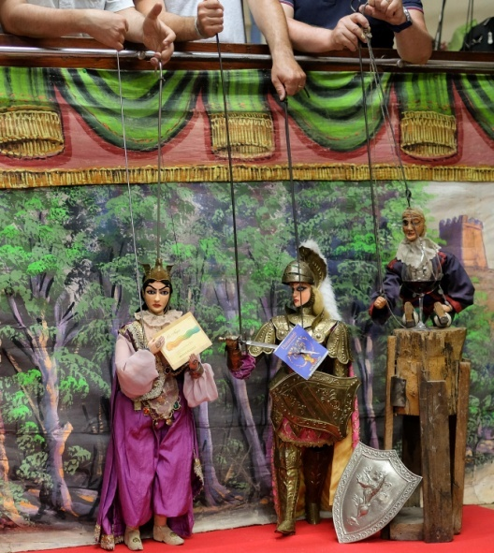
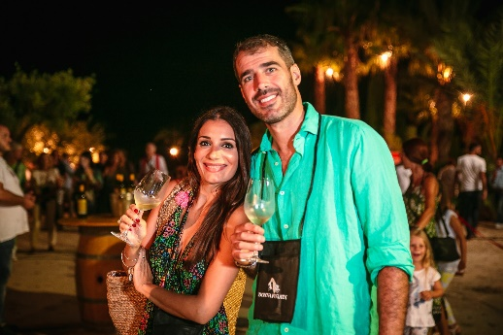
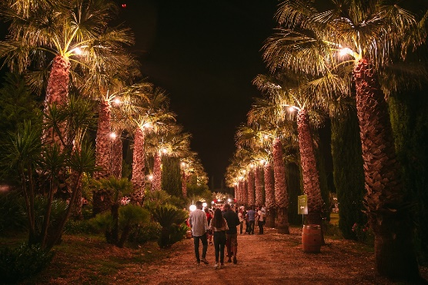
The Sicilian Puppet Opera in the Contessa Entellina vineyard and the launch of the Chardonnay night harvest

We are counting down to the sold-out event in Contessa Entellina, in the heart of the Sicilian countryside: August 10 will be the night of Calici di Stelle, the most anticipated summer event promoted by the Wine Tourism Movement.
That of 2019 will be the 22nd edition held at the Donnafugata Estate: an evening dedicated to those who love wines and Sicily, and that this year will be enlivened by the magic of the Puppet Opera.
Once again devoted to the relationship between Art and Wine, this year the public of Calici di Stelle will be captivated by the Fratelli Napoli Company, one of the most important dynasties of puppet theatre.
"We asked the Fratelli Napoli - says José Rallo of Donnafugata - to present two female characters, of great charisma, who would recall the personality of the same number of wines of the company. Wine lovers will toast in the moonlight, following the exploits of Angelica in combination with the tasting of Chardonnay La Fuga and those of Bradamante with the red Floramundi, Cersasuolo di Vittoria.
Calici di Stelle will also be an opportunity to talk about the progress of the vintage. "Today there is a slight delay in ripening - says Antonio Rallo of Donnafugata - with a lower production in quantity but of excellent quality; on August 7 we commenced the harvest of Chardonnay for the base sparkling wine; also, coming to perfect maturity is the Chardonnay of Contrada Duchessa at Contessa Entellina: in little more than a hectare of vineyard, we expect that on the 10 of August it will be harvested at night, to preserve the best aromatic components.” As this is a vineyard far from the venue of the event, Donnafugata will broadcast some phases of the harvest LIVE on the DonnafugataWine social network channels from 10pm.
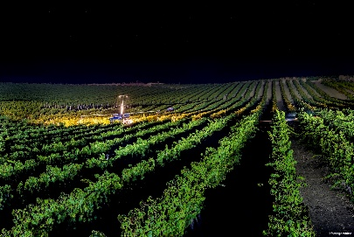
After visiting the vineyards and the winemaking cellar, the night of Calici di Stelle will continue in the charming garden of Donnafugata, where all the wines produced by the company in its different estates can be tasted: in Contessa Entellina, Pantelleria, on Etna and in Vittoria, a kaleidoscope of terroirs, vines and oenological interpretations in pure Donnafugata style.
There will be over 30 labels to taste: the iconic wines Mille e Una Notte and the Passito di Pantelleria Ben Ryè, to which will be added a special selection of 14 rare historical vintages, now out of circulation.
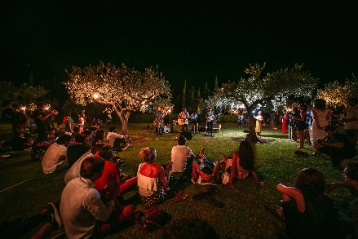
A special focus will be dedicated to the reds produced on Etna: the iconic wine Fragore, cru of Contrada Montelaguardia and Sul Vulcano, both expressions of the native variety Nerello Mascalese. It will also be an opportunity to learn about the new welcome project in the winery of Randazzo, which will open to the public on August 19.
Following the tradition, in the olive grove, at the end of the tasting, there will be live music by the Fancies, a band from Palermo, the capital of the region, which, amongst Italian-made songwriters, Chicago Blues, 1960s British Invasion rock and retro electronics, will animate another memorable edition of Calici di Stelle in Donnafugata.
Calici di Stelle: 10 August 2019, from 21:00 to 01:00 - Donnafugata, km 60 S.S. 624
https://visit.donnafugata.it/it/eventi/contessa-entellina/calici-di-stelle-2019-2
Ticket: pre-sale online until places are exhausted, 25 euros plus 5 euros deposit for the glass; possibility to buy on-site for 35 euros + 5 euros deposit for the glass; free ticket for children under 18 years.
Marsala, 8 August 2019
PRESS OFFICE Nando Calaciura calaciura@granviasc.it cell. 338 3229837
PUBBLIC RELATIONS Baldo M. Palermo baldo.palermo@donnafugata.it tel. 0923 724226

FURTHER DETAILS

Donnafugata supports the Marionette Museum in Palermo
The collaboration with the Fratelli Napoli has brought Donnafugata into contact with the Antonio Pasqualino International Museum of Marionettes in Palermo, which houses part of their collection and, in total, more than 5,000 pieces including marionettes, puppets, dolls, shadow puppets, stage equipment and posters from around the world.
Thus arose the spontaneous desire to contribute to the restoration and maintenance of the Museum's vast heritage, with three years of financial support that Donnafugata will begin to provide this year.
The first puppets to be restored in 2019 will be two historical puppets from the Museum's collection: Angelica and Carinda (the oldest in the Museum, dating back to 1828), valuable pieces in need of urgent restoration; a choice of responsibility and promotion of the territory, in line with the values that have always guided the company.

Visiting Donnafugata
In the 90s Donnafugata opened its cellars to wine lovers, to share and spread the culture of wine. The welcome is characterized by a fun and educational approach that aims to maximum the involvement of enthusiasts.
A style of hospitality that visitors can experience all year round in the historic cellars of Marsala and, in the summer months, in the agricultural company of Pantelleria.
From 19 August, the Donnafugata winery on Etna in Randazzo will also be open to the public. The guided tours will lead to the discovery of the vineyards, the barrique cellar overlooking the volcano and conclude with professional tastings in the small and welcoming winery, guiding the wine lovers to the discovery of a unique territory, of volcanic soil, with its mineral wines endowed with great complexity.
Another important novelty is the website entirely dedicated to the welcome in the cellar and events. https://visit.donnafugata.it/it/ which also enables the online purchase of tastings and also offers rich information on the territory.

