PRESS RELEASE
Discovering Donnafugata on Etna
Inaugurated at the Randazzo winery various tours to discover the local viticulture and the small prestigious productions of the company, to enjoy involving and memorable experiences.

Active since the 2016 harvest, Donnafugata's cellar on Etna is finally opening to the public; this news has been long-awaited by the company's fans and by many wine enthusiasts who now have a new wine destination in eastern Sicily.
The beating heart of the welcome is the Randazzo wine cellar, in the Statella district, in a strategic position compared to the 18 hectares of vineyards that Donnafugata has within a few kilometres in 6 different districts.
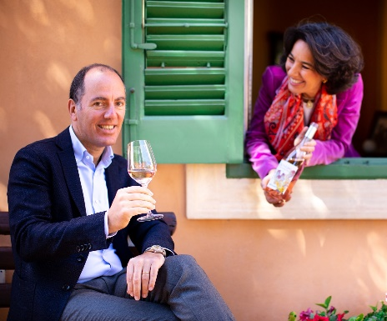
It is here that Donnafugata - led by Antonio and José Rallo - has taken root, north of the volcano, on the less rainy side and therefore with a greater chance of producing well-matured grapes and at the apex of the quality of the prestigious DOC Etna. Its evocative landscape is dominated by the highest (over 3,300 meters) and most active volcano in Europe, with a heritage of biodiversity that the Etna Park protects and encloses in an area of 59 thousand hectares, and that UNESCO has declared a World Heritage Site.
Tours and tastings on Mount Etna follow the refined and involving style that thousands of wine lovers have already experienced over the years at the company's other locations in western Sicily: the historic cellars of Marsala, the island of Pantelleria and the Contessa Entellina Estate.
In Randazzo, stopping off at Donnafugata means finding yourself in an enchanting part of the Etna Park, at an altitude of 700 metres, amidst evergreen woodland, grazing cows and vineyards, some of which are so old as to be pre-phylloxera.
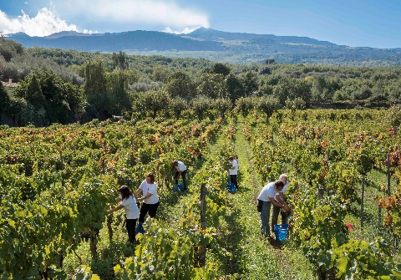
The visits begin with a presentation of the territory and its pedoclimatic characteristics. An outdoor itinerary during which - walking in the vicinity of the wine-cellar - the visitor is guided to the discovery of the sciare: stratifications of lava that, through long physical-chemical processes, give life to the sandy and cultivable soils on the slopes of the volcano. Each eruption is thus at the origin of the specific composition of the soil that makes the micro-terroirs of Etna and its wines unique.
Then there is a stroll through the vineyard to get to know the local viticulture and its emblematic vines - Carricante and Nerello Mascalese - the planting patterns, the forms of cultivation and pruning; then it is the turn of the winemaking cellar and the new barrique cellar with a view of "A Muntagna", as Etna is called by the locals.
The experience at Donnafugata is sure to be memorable for the wine and so here is a proposal of four tasting itineraries designed to meet different expectations, for those who are beginning to approach wine or for those who want to deepen their knowledge.
“Etna 100%” proposes a focus on Nerello Mascalese through 3 different interpretations represented by the wines Sul Vulcano Rosato, Sul Vulcano Rosso and Fragore, cru of Contrada Montelaguardia; those who love to experiment with food and wine pairings, can instead choose the “Brunch Gourmet” which includes 4 wines with as many creations of Etna cuisine.
In the afternoon, two other itineraries complete the offer. “Sicilia Autoctona” is the ideal tasting to get to know the main vines of the island through the small and prestigious productions of the different Donnafugata estates: the SurSur from Grillo grapes of the Contessa Entellina countryside, the Floramundi Cerasuolo di Vittoria from Nero D'avola and Frappato grapes, the iconic Fragore wine from Nerello Mascalese of Contrada Montelaguardia and finally the Ben Ryé, the celebrated Passito di Pantelleria obtained from Zibibbo grapes. Finally, with “Vulcanica” you can experience an exciting journey between Etna and Pantelleria, tasting 4 wines produced in these territories of volcanic origin, in an exciting comparison between mountain viticulture and the eroica one of the island of sun and wind.
All the itineraries are just a click away, thanks to the VISIT website that offers a wide range of information on visits and tastings in Donnafugata, including the possibility of online booking.
Inaugurating the welcome at Randazzo, Donnafugata wanted to add a piece to the mosaic of beauty with which Etna enchants its guests; between an excursion at high altitude and a visit to the characteristic villages of the area, the wine celebrates the harmony between nature and the work of man. And it is worth the journey, the discovery and the wonder that comes with it.
Donnafugata, 26 August 2019
PUBLIC RELATIONS Baldo M. Palermo baldo.palermo@donnafugata.it tel. +39 0923 724226
Laura Ellwanger pr.international@donnafugata.it tel.+39 0923 724258
PRESS OFFICE Nando Calaciura calaciura@granviasc.it cell. +39 338 3229837

