PRESS RELEASE
Donnafugata and the art of recounting wine in one minute
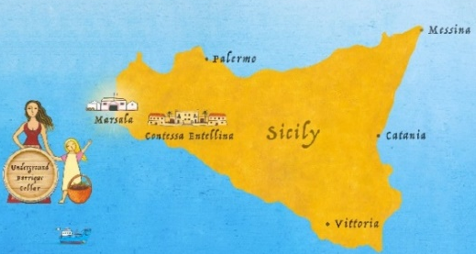
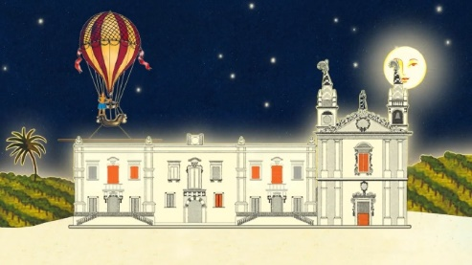
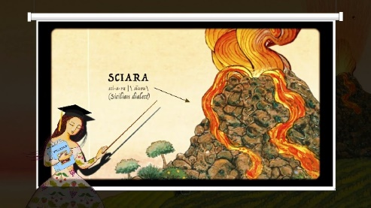
The Sicilian company is innovating the communication of its wines with a series of animated video-stories in which the fantastic and feminine universe of its labels comes to life in a surprising way.

If producing wine is an art, so is telling its story. For this reason, Donnafugata, since the early '90s, has innovated communication by introducing on its labels female figures, Sicily and its colours, through the illustrations of the artist Stefano Vitale. Almost 30 years after its inception, the packaging of the Sicilian company is one of the most distinctive and represents, when it comes to quality wine, an extraordinary success story.
And now that fantastic universe - populated by the evocative female figures of Anthìlia, Sherazade, Floramundi, Bell'Assai - comes alive in a startling way, to reach an ever-widening public through videos and social channels. Thanks to the creative flair of producer and video-maker Virginia Taroni, the series Un minuto per un vino (One minute for a wine) was launched: the first 6 animated stories in the series are on the company's YouTube channel; the first one has already been broadcast on the social channels @DonnafugataWine and the others will follow shortly.
From the rich heritage of Donnafugata labels, the author has derived countless iconographic elements, sometimes as they are, sometimes transformed or reinvented, infusing them with life and action, with the techniques of Video-Animation. With the fast pace of social communication and with the greatest communicative efficacy, each wine is recounted in just one minute, in all its main aspects: the meaning of the name, the territory of origin, the vines, the production process, the organoleptic characteristics, and the suggested pairings with food.
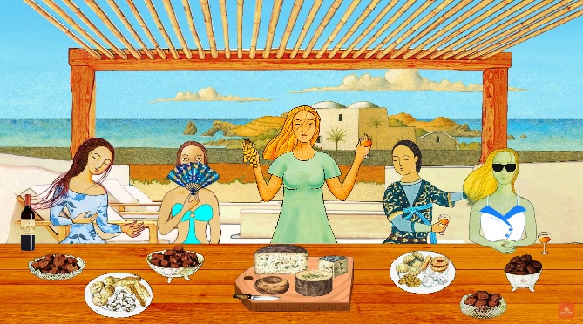
The narrator's tone of voice manages to amuse and excite in an original way and makes these animated stories little masterpieces, consistent with the dreamlike dimension of the imaginary Donnafugata. So it happens that the sea around Sicily is traversed by giant squids or sea dragons, the sky is crisscrossed by hot air balloons and, in a creative crescendo, the figures of woman-in-flight, who identify the celebrated labels of the Sicilian company, meet around the table to share in the pleasures of food and wine.
The final settings are brilliant in their inventiveness: in the video dedicated to Ben Ryé, the women-in-flight are on the seashore of Pantelleria, in swimsuits and sunglasses; in that of the Mille e una Notte they are in a ballroom-style hall of the Leopard; while in the video that presents the cru of Etna Fragore, the protagonists toast inside a spaceship, a metaphor of a company in perpetual motion towards new objectives.
From the illustrations of Stefano Vitale to the animations of Virginia Taroni, Donnafugata recreates a new and engaging narrative of Sicily, the island of myth and wine, in an artistic key.
Marsala, October 30th, 2019
Donnafugata Public Relations: Baldo M. Palermo baldo.palermo@donnafugata.it tel. +39 0923 724226
Laura Ellwanger pr.international@donnafugata.it tel. +39 0923 724258

Donnafugata Press Office: Nando Calaciura calaciura@granviasc.it cell. 338 3229837

