PRESS RELEASE
The 2019 Donnafugata Grape Harvest
The trend of the vintage at Contessa Entellina, Pantelleria, Vittoria and Etna.
At Contessa Entellina in the heart of western Sicily, the 2019 vintage was less precipitous, with 546 mm of rain compared to the average of 660 mm*. Much of the precipitation was in winter and spring, while the summer was quite dry. The careful management of agronomic practices, from pruning to thinning through to the choice of different harvesting times, ensured that the grapes were healthy and well ripened. *The precipitation data are collected by SIAS, Sicilian Agrometeorological Service; the rainfall recorded from October 1st to September 30th of the following year is taken into account; the average is calculated starting from the 2003 harvest.
The quantity produced was lower than in the last two years. This result was influenced by the particularly cold spring.
The harvest began on 7/8 with the harvesting of Chardonnay and Pinot Noir for the production of sparkling wines of the classic method, Brut and Brut Rosé. The harvest of Chardonnay La Fuga took place in the second ten days of August, and was followed by that of Sauvignon Blanc and Viognier. Most of the autochthonous whites -Grillo, Ansonica, Grecanico and Lucido (Catarratto) - were harvested between the first and second ten days of September, while some of the vineyards of Grillo and Ansonica from the higher districts were harvested in the last ten days of September. The harvest of the whites ended on 26/9.
Among the red grapes, the first variety to reach maturity was the Merlot, in the last ten days of August, followed by Nero d'Avola and Syrah. The harvest of Tannat, Petit Verdot and Cabernet Sauvignon took place between the first and second decade of September.
In Pantelleria, where Donnafugata cultivates 68 hectares of vineyards located in 14 different districts, the 2019 vintage was slightly rainier, recording 505 mm of precipitation compared to the average of 466 mm*. The quantity of Zibibbo produced was lower than in the last two years. This result was influenced by the particularly cold and windy spring. The harvest began on August 19 and ended on September 12.
* The rainfall recorded from 1 October to 30 September of the following year is taken into account; the average is calculated starting from the 2013 harvest.
In south-eastern Sicily, in Acate, Donnafugata cultivates 36 hectares of vineyards and produces Frappato and Cerasuolo di Vittoria. In this territory, the climatic trend of the vintage was quite regular with slightly above average rainfall and mainly concentrated in spring and some days of summer. The careful agronomic management favoured a harmonious vegetative-productive cycle giving life to grapes that have reached the right level of sugary, aromatic and phenolic ripeness.
The quantity produced was lower than in the last two years; the particularly cold spring had an influence on this result. The harvest time was chosen with extreme care: the Frappato vineyards were harvested between 20/9 and 3/10; the Nero D'Avola harvest took place from 21/9 to 2/10.
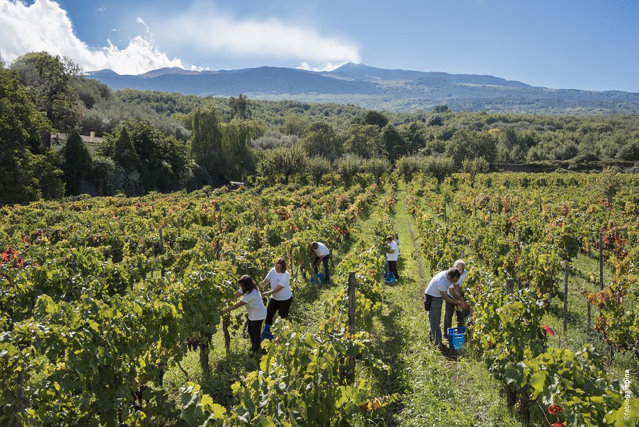
On Etna, where Donnafugata cultivates 18 hectares of vineyards in six different districts between Randazzo and Castiglione di Sicilia, the 2019 vintage was cool and with average rainfall; a typical Etnean vintage with rainfall also recorded in spring and summer, quite usual for vineyards over 700 m. above sea level; in particular, the rains between mid-August and early September brought out the freshness and aroma. On this side of the volcano the following weeks were dry; this climatic factor, together with the choice to carry out some thinning, favoured the desired ripening and the regular harvesting.
The Carricante harvest began on 30/9 and ended on 10/10. The Nerello Mascalese harvest took place with several stages in the same vineyards: from 05/10 with the selection of the clusters for the production of the rosé wine; while for the production of the reds the harvest continued from 14 to 19/10 in the district of Montelaguardia, and from 19 to 21/10 in the district of Marchesa.
The white and rosé wines of 2019 are particularly fragrant and have an excellent acid structure; the reds are very elegant and have an extremely fine and well integrated tannin.
Marsala, 6th of December, 2019
PRESS OFFICE Nando Calaciura calaciura@granviasc.it cell. +39 338 3229837
PUBLIC RELATIONS Baldo M. Palermo baldo.palermo@donnafugata.it tel. +39 0923 724226
Laura Ellwanger pr.international@donnafugata.it tel. +39 0923 724258

