PRESS RELEASE
Harvest 2020 at Donnafugata
The trend of the vintage in Contessa Entellina, Pantelleria, Vittoria and on Etna.

The harvest at Donnafugata lasts almost 100 days, covering four different territories of Sicily, an island that can be considered a wine-growing continent due to its great diversity of vines and terroirs.

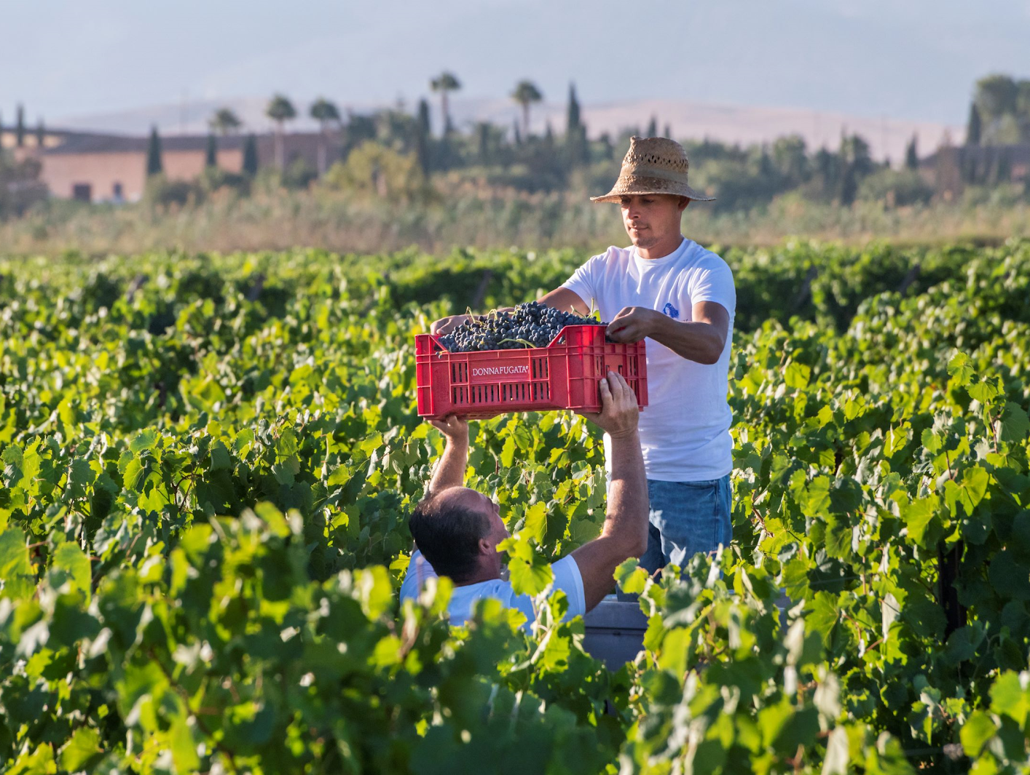
At Contessa Entellina in the heart of western Sicily, the 2020 vintage was characterised by less rainfall, recording 437 mm of rain compared to the average of 647 mm*. Most of the rainfall occurred in winter and spring, while the summer was essentially dry. Careful management of agronomic practices, from pruning and thinning to the choice of harvesting times, resulted in perfectly healthy and ripe grapes.
The harvest began on 1 August with the picking of the Chardonnay for the Metodo Classico sparkling wine and continued between August and September, according to the ripening periods of the different varieties; the 2020 harvest ended on 11 September, about 10 days earlier than the average for this area. Overall, the quantity of grapes produced was slightly lower than the company averages. The 2020 vintage yielded wines with good aromatic intensity and structure.

On the island of Pantelleria, the year 2020 was slightly less rainy, with 433 mm of rain compared to the average of 462 mm. Harvesting of the Zibibbo grapes began on 17 August in the most precocious district such as Punta Kharace; these grapes were mainly destined for drying to produce the Passito Ben Ryé. Harvesting then gradually continued according to the ripening times of the Zibibbo in the various districts where Donnafugata has its vineyards, which differ in altitude and exposure, such as Khamma, Karuscia, Bukkuram, Tracino, Bugeber, Favarotta, Gibbiuna, Serraglia, Monastero, Mueggen, Barone and Ghirlanda. The 2020 harvest ended on September 9; the quantity produced is in line with the average production of Donnafugata on the island; the quality of the grapes brought to the cellar is excellent. The wines of the 2020 vintage stand out for their aromatic intensity and excellent freshness.

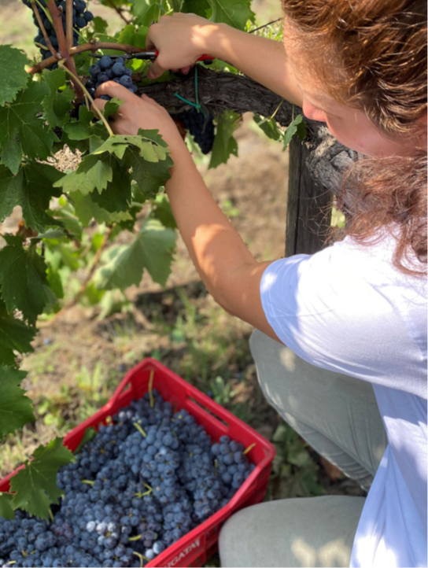
At Acate, in the area where Frappato and Cerasuolo di Vittoria are produced, the less rainfall recorded in the vintage (281mm compared to the average of 410 mm) were compensated by irrigations which favoured the regular vegetative-producing cycle; the Frappato and Nero d'Avola grapes therefore reached ideal sugar, aroma and phenolic ripeness, the prerequisite for wines of particular fragrance and pleasantness. Harvesting of the Frappato began on 7 September and that of the Nero d'Avola on 8 September; the harvest continued regularly over the following weeks according to the gradual ripening of the grapes in the various vineyards of the estate; the harvest ended on 2 October; the quantity and quality of the 2020 vintage fully reflected the company's objectives.

On the northern slope of Etna, Donnafugata grows Nerello Mascalese, Carricante and a small amount of Nerello Cappuccio, in the territories of Randazzo and Castiglione di Sicilia. The 2020 vintage was characterized by regular climate conditions with a cold winter, a mild spring and a summer with good temperature excursions; 792 mm has been the total rainfall recorded which is in line with the territory’s average of 801 mm. Therefore, the vegetative cycle was balanced and produced healthy, well ripened grapes. The harvest began on 21 September with the Nerello Mascalese grapes destined for the production of rosé wine and continued on 23 September with the harvesting of the Carricante grapes; the red wine harvest took place in the following weeks and ended on 11 October. The quantity produced was in line with the company's expectations; the wines of this vintage stand out for their great finesse and minerality.
Marsala, November 30th, 2020
PRESS OFFICE Nando Calaciura calaciura@granviasc.it cell. 338 3229837
PUBLIC RELATIONS Baldo M. Palermo baldo.palermo@donnafugata.it tel. 0923 724226

