PRESS RELEASE

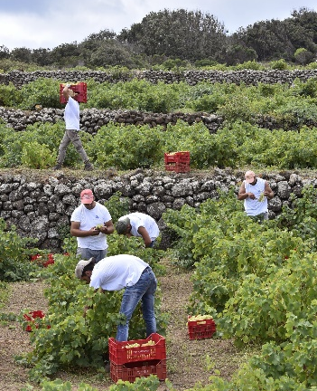
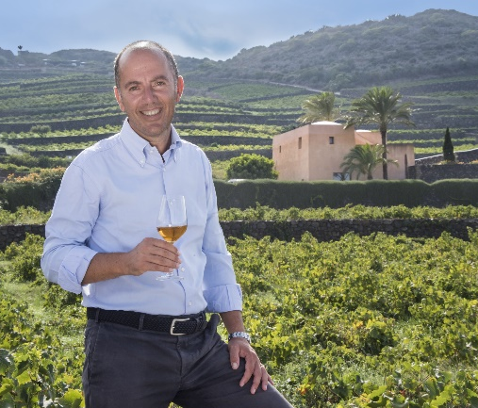
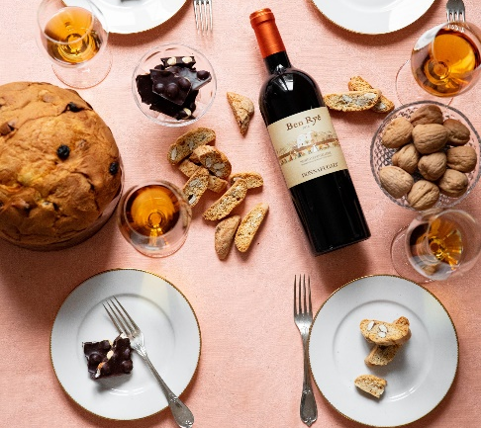
Ben Ryé Passito di Pantelleria, awarded by the most important Guides
The Donnafugata’s iconic wine has received the highest recognition from the most prestigious Italian and international wine guides.
This has been a great year for Ben Ryé: Donnafugata’s Passito di Pantelleria achieved the highest recognition of all the most important Italian wine guides; from Gambero Rosso to Doctor Wine, from Veronelli to Slow Wine, from Bibenda to Maroni, from Vini Buoni d’Italia to Vitae. A unanimous accolade that places Ben Ryè at the top of the Italian fine wines and emphasizes the uniqueness of this iconic wine.
Further to this, according to international reviews, Donnafugata’s Passito stands as a benchmark among the most prestigious sweet wines such as Sauternes, Tokay and Mosel. Other recognitions came from Falstaff, Vinous and Wine Spectator, which have also highly rated Ben Ryé.
The iconic Donnafugata Passito di Pantelleria was showcased in two special vertical tastings, one by James Suckling and another one, in London, run by Gabriele Gorelli, Master of Wine, together with Josè Rallo and Pietro Russo from Donnafugata.
“Our Ben Ryé - Antonio Rallo from Donnafugata states - is born in Pantelleria, an island known by its challenging natural conditions such as lack of water sources, strong winds or steep slopes. The vine is trained as “Alberello Pantesco” (low-bush vine); all the agricultural practices need a lot of manual work from the pruning to the destemming of raisins, including the maintenance of 40km of dry lava stone walls in our 68 hectares of vineyards. A heroic viticulture to which Donnafugata has been dedicating for over 30 years and the results achieved this year reward our team’s commitment - Antonio Rallo concludes - to whom we express our gratitude.”
Marsala, December 22nd, 2022

PUBLIC RELATIONS
Emanuele Corsale emanuele.corsale@donnafugata.it

Laura Ellwanger pr.international@donnafugata.it

Ben Ryé in the international Guides: 96 Decanter, 94 Falstaff, 95 James Suckling, 94 Wine Spectator, 96 Vinous.

Ben Ryé 2019 in Italian Guides 2023: Tre Stelle Oro for Vini di Veronelli, Tre Bicchieri for Vini d'Italia Gambero Rosso, Cinque Grappoli for Duemilavini Bibenda of the Italian Sommelier Foundation, Vino Top for Slow Wine by Slow Food, Faccino for la Guida Essenziale ai Vini d'Italia by Doctor Wine, Quattro Viti by Vitae of the Italian Sommelier Association, Corona for Vinibuoni d'Italia e Vino Frutto per Annuario dei Migliori Vini Italiani di Luca Maroni.

