PRESS RELEASE

Nomacorc Ocean, the new Vinventions wine closure that helps to protect the oceans: a world premiere for Donnafugata

The new Vinventions closure is the first in the world to be produced by recycling plastic collected in coastal areas and destined to end up in the oceans (Ocean Bound Plastic). For the worldwide launch of this project, Vinventions has partnered with Donnafugata: The historic Sicilian winery will be the first to use the Nomacorc Ocean cap on its bottles of Damarino wine. This collaboration is based on sharing the same values for environmental sustainability.

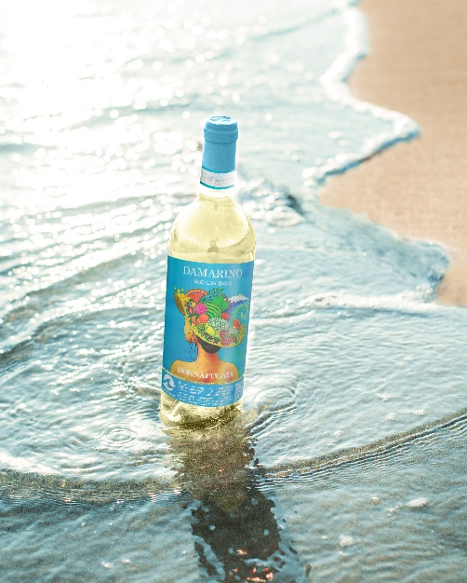
Protecting the oceans, making plastic a renewable resource: Nomacorc Ocean is the first wine closure in the world made of recycled plastic from coastal areas. Vinventions chose Italy for their worldwide launch and partnered with Donnafugata, a leading Italian winery: The Sicilian company, which can boast a thirty-year commitment to environmental and social sustainability, was considered the ideal partner to present Nomacorc Ocean.
Damarino, Sicilia DOC Bianco, is the first wine in the world to use a cap produced by recycling plastic collected in coastal areas, to avoid ocean pollution. Today, with Nomacorc Ocean, Vinventions takes another step forward in protecting the planet by offering a closure that contributes to the preservation of marine ecosystems, in line with the United Nations 2030 Agenda.
Numerous actions are being taken around the world to limit marine pollution, an issue of great concern. Some of these initiatives aim at blocking and recovering waste before it reaches the sea: among these is Nomacorc Ocean, which uses raw material from this waste to give it a second life, according to the principles of the circular economy. This waste is called Ocean Bound Plastic, or OBP; Plastic waste recovered in coastal regions where collection systems are insufficient or nonexistent, and where pollution risks are highest.
“Based on the scientific literature, OBP is estimated to generate 80 % of plastic marine litter. By pioneering a closure that uses OBP, the aim is being part of the value chain, at our scale, to increase the demand for harvesting plastic waste before it pollutes our oceans. The OBP used in Nomacorc Ocean is collected from Southeast Asian beaches and islands, in areas where waste collection really matters and has an impact, as this has been proven that Asia is where rivers emit the most plastic into oceans,” says Romain Thomas, Nomacorc Product Manager at Vinventions.
“We are proud of this partnership with Vinventions for the launch this project – explains Josè Rallo, owner of Donnafugata with her brother Antonio – because it strengthens our commitment to environmental sustainability with tangible results: Thanks to the introduction of this wine closure on our Damarino wines, we contributed to the recycling of 1.15 tons of OBP”. “Technically it is one of the most widely-used closures with proven performance in the wine supply chain - continues Antonio Rallo - but it is the type of materials and their origin that are truly innovative; Nomacorc Ocean reinforces our commitment to safeguarding the environment, especially the seas and oceans".
Vinventions and Donnafugata aim to provide their customers and the final consumer the opportunity to contribute to the oceans’ protection through their purchasing choices contributing to the achievement of goal 14 of the UN Agenda 2030 which aims to conserve and sustainably use the oceans, seas and marine resources for sustainable development
February 1st, 2023
DONNAFUGATA
PUBLIC RELATIONS Laura Ellwanger pr.international@donnafugata.it
Emanuele Corsale emanuele.corsale@donnafugata.it
VINVENTIONS
PRESS OFFICE Matteo Tagliapietra info@winedreamers.com cell. 3386763980
MARKETING & COMUNICATIONS : Vanessa Sferrazza vanessa.sferrazza@vinventions.com

Donnafugata: Donnafugata was born in Sicily from the initiative of a family, with over 170 years of experience in quality wine, that innovated the style and perception of Sicilian wine in the world. Today José and Antonio Rallo, the fifth generation, lead the company and a team of people oriented towards excellence. Donnafugata is craftsmanship and produces its wines in unique territories and vineyards across Sicily: in Contessa Entellina, where Donnafugata was born, in Pantelleria, the island of sun and wind, on Etna, the highest active volcano in Europe, and in Vittoria, known for the homonymous DOCG. With over 30 years of adopting good practices in various areas, sustainability is part of the company's DNA, including the vineyard, the carbon footprint, biodiversity, the enhancement of native varieties, energy efficiency, and sustainable architecture. In line with the UN 2030 Agenda, Donnafugata joined the SOStain Sicilia foundation in 2021, the sustainability program for Sicilian viticulture, strengthening its commitment to Environmental, Social, and Governance Sustainability.

Vinventions: Vinventions is the world's most comprehensive provider of wine closure solutions designed to support the diverse needs of winemakers. Vinventions provides closure solutions that maximize performance, design and sustainability. Its brands include Nomacorc Green Line and Blue Line, SÜBR (micro-natural), Vintop (screwcaps) and Wine Quality Solutions which includes enological devices, equipment and services that improve the quality and consistency of wine through quality control in real time. Vinventions employs more than 550 associates worldwide and operates manufacturing sites in the United States, Belgium, France, Italy, Argentina, South Africa and China. Vinventions' leadership values are customer proximity, innovation, empowerment, open teamwork, sustainability and long-term responsibility.

