Donnafugata together with Dolce&Gabbana
to celebrate the beauty of Alta Moda in Puglia
The most evocative locations of the Valle d’Itria formed the backdrop to the annual Dolce&Gabbana Alta Moda events. The wines of the collection created in collaboration with Donnafugata were also on show
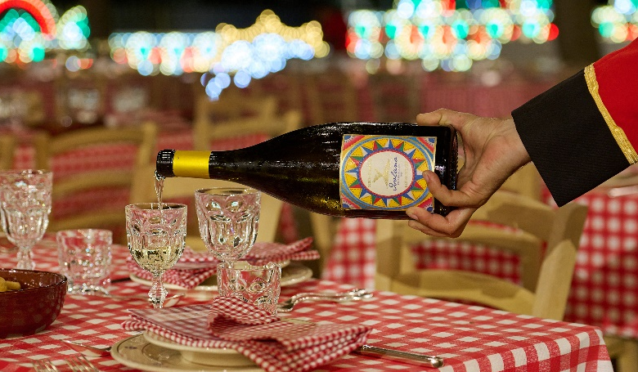
From 8 to 11 July 2023, the Valle d’Itria was the location for a series of spectacular Dolce&Gabbana events dedicated to the unique Alta Moda, Alta Sartoria and Alta Gioielleria collections.
The values of Italian creativity and artisanship, distinctive traits of the wines jointly produced by Dolce&Gabbana and Donnafugata, met the unmistakable flavours of Puglia in a celebration of authentic Italian hospitality.
In Fasano, Alberobello and Ostuni, all eyes were on the Rosa rosé, the elegant volcanic wines of Etna - the Isolano white and the Cuordilava red - as well as the prestigious Tancredi red.
Fascinated by the colour pink, Dolce&Gabbana were particularly keen on producing the Rosa wine. This select wine was created from an original blend of two of the island’s most traditional native grapes: Nerello Mascalese and Nocera.
Isolano is an enveloping white bursting with character which is produced on the northern slopes of Etna from a careful selection of Carricante grapes.
Cuordilava is an elegant red produced on the slopes of Etna from Nerello Mascalese grapes. The incredible personality of Cuordilava is enhanced by its strong ruby red colour that recalls the lava of the volcano as it bursts from the crater with all its energy.
Tancredi is the historic red that Donnafugata has dedicated to its partnership with Dolce&Gabbana. A “revolutionary” wine, created in 1990 from what was an innovative blend at the time: the international Cabernet Sauvignon and the native Nero d’Avola. The name Tancredi brings to mind one of the main characters in the novel “The Leopard”, an inexhaustible source of inspiration also for Dolce&Gabbana.
With this celebration of the beauty of Alta Moda in Puglia, the partnership between Donnafugata and Dolce&Gabbana, which for years has promoted the values of Italian excellence all over the world, therefore continues to go from strength to strength.
Marsala, July 11th, 2023
PUBLIC RELATIONS
Baldo M. Palermo baldo.palermo@donnafugata.it tel. 0923 724 226
Emanuele Corsale emanuele.corsale@donnafugata.it tel: 0923 724 225

