PRESS RELEASE
Calici di Stelle: immersive experiences where wine meets art and nature
A calendar of moonlight events to celebrate wine in the beautiful gardens of Donnafugata. Headline event on 10 August at Contessa Entellina with an incredible immersive and multisensory experience. Calici di Stelle runs from 4 to 20 August with sophisticated tastings and artistic performances at the Vittoria, Pantelleria, Etna and Marsala Estates.

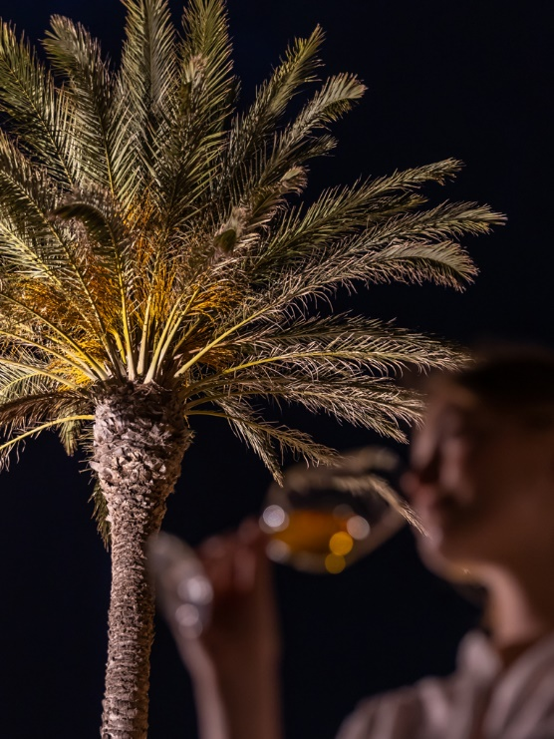
Calici di Stelle returns with the most highly anticipated events of the summer, promoted by Movimento Turismo del Vino. Between 4 and 20 August, Donnafugata will be promoting an engaging calendar of events at all its Estates.
With the 2023 edition, Donnafugata celebrates wine but also the sustainability and beauty of the gardens that make its Estates such special places. Representing a bridge between culture and agriculture, the gardens are in fact the perfect blend of the agricultural and natural landscapes.
The multisensory experience, created through this new vision of the garden, is enhanced with the lights, colours and images that will take centre stage during the headline evening of 10 August at Contessa Entellina, which will once again be attended by hundreds of wine lovers.
The tour and tasting in “Gabriella’s Garden”, named after the founder of Donnafugata, will involve the degustation of 30 wines, including vintages from the company’s historic reserve, and will be richly animated with lots of creative multimedia content. Videomapping, interactivity and audiovisual performances will enhance the tasting of Donnafugata wines, expression of a unique and remarkable land. An immersive experience in an environment where nature meets technology, exploring new languages of art in an original and memorable way.
For this special event Donnafugata has enlisted the talents of multimedia artist Filippo Gualazzi, founder of Quadro Quantico, and electro-ambient music duo FF, represented by Vincenzo Marcone.
Wine lovers will be greeted by a videomapping animated with a few details of the labels created by Stefano Vitale and by illustrations of the gardens by Julia Binfield, an intriguing projection which, together with sounds, will evoke the nature of the Mediterranean, rich in biodiversity and tradition, with the goal of finding a new balance between man and nature.
In the olive grove Donnafugata fans will be able to experience the new interactive technologies themselves thanks to an installation that captures the movements of their bodies, generating forms and colours. Visitors to Calici di Stelle will therefore be able to have fun creating their own works of art, just by moving, using a virtual palette.
The event will culminate with a live audiovisual performance that reinterprets the rich biodiversity of the Estate. Specifically for the event, a score will be written that reproduces the natural elements of “Gabriella’s Garden” in a contemporary symphony: homage will be paid to the imaginative universe of an enchanting Sicily, represented by the world-renowned communication style of Donnafugata.
Involving all the Estates and production sites, Calici di Stelle at Donnafugata guarantees an event-filled August. Prior to the event at Contessa Entellina on the 10th, the night of the shooting stars, the programme will open at the Vittoria Estate on 4 August before subsequently visiting Pantelleria on the 13th, Randazzo on Etna on the 18th and finally the historic cellars of Marsala on 20 August.
The Calici di Stelle events on Etna, at Vittoria and at Marsala are reserved for a limited number of visitors and involve a tour and a refined tasting of seven wines paired with typical local delicacies. The experience will culminate with an exclusive light painting performance by Sicilian artist Fabio Ingrassia, a visual and emotional representation of the gardens of Donnafugata resulting from the dialogue between art, wine and sustainability.
The evening at Pantelleria will begin at sunset with a captivating walk through the vineyards of Khamma. After this, Giardino Pantesco (Pantellerian Garden), donated by Donnafugata to the FAI - Fondo per l’Ambiente Italiano (Italian National Trust): a magical place where the first wine will be tasted. This will be followed by a tour of the cellar and the sophisticated wine and food pairings with the tasting of six more labels, including two vintages of the iconic Italian sweet wine, Ben Ryè passito.
Tickets for the Calici di Stelle evenings are available in advance, subject to availability, from https://visit.donnafugata.it/it/calici-di-stelle-2023.
Marsala, 25 July 2023
DONNAFUGATA
PUBLIC RELATIONS
Emanuele Corsale emanuele.corsale@donnafugata.it tel. +39 0923 724 225
Baldo M. Palermo baldo.palermo@donnafugata.it tel. 0923 724 226

