PRESS RELEASE
The 2023 harvest at Donnafugata
The trend of the year in Contessa Entellina, Pantelleria, Vittoria, and Etna.
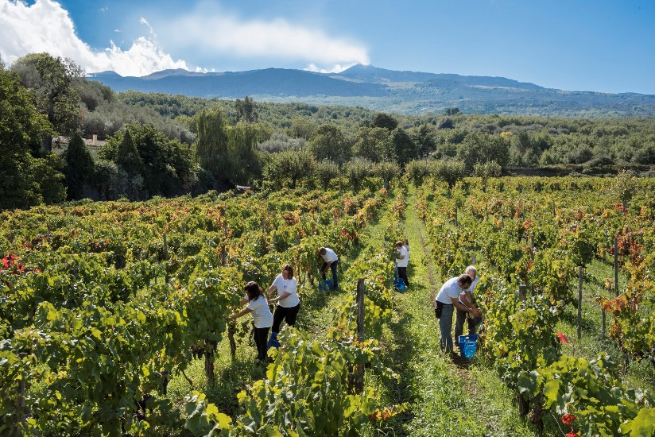
The 2023 harvest was particularly challenging as it required continuous monitoring of alternating climatic conditions and the adoption of targeted agronomic choices.
After a winter with little rain, the abundant rains in May guaranteed an optimal water supply to the soil which allowed the vineyards to better cope with the high temperatures that lasted for about ten days in July. The heat had the effect of slowing down the vegetative-production cycle which returned to normal from the end of July onwards thanks to the ideal climatic conditions of the following weeks.
At the Vittoria Estate, the quantity of grapes produced was almost in line with the average of recent harvests; in the Contessa Entellina, Pantelleria and Etna estates there was a drop in production compared to the average of recent years, above all due to the production of slightly less compact bunches and with smaller and lighter berries. In the case of the reds, the small grapes favored excellent phenolic maturation with a high concentration of tannins, a prerequisite for wines with good structure and significant longevity potential.
Thanks to the meticulous management of the vineyards, the 2023 harvest produced well-ripe grapes, the premise for rosé wines with very good fragrance, whites with excellent acidity and aromatic finesse, reds with well-integrated tannins and with considerable potential for evolution.
In the Contessa Entellina estate, in the heart of Western Sicily, a total of 604mm of rainfall was recorded compared to the average of 662mm. The agronomic and eco-sustainable management included integrated pest control interventions, green manure, and the use, for the first time, of ties made of mater-bi, a completely compostable material of organic origin. For more efficient use of water resources, leaf water potential was monitored to carry out emergency irrigation only in the vineyards where it was useful.
The harvest began with a delay of 7-10 days, in early August; the first grapes harvested were those for the production of the Classic Method sparkling wine base. The harvest then began in earnest in the second half of August and continued according to the ripening period of the 19 vines grown on this estate, concluding on September 25th. There was a lower production than the average of this estate, of a quality perfectly in line with the winery's objectives.
Even at the Pantelleria estate, the 2023 vintage was characterized by careful agronomic practices which - in this context of heroic viticulture - involve a high contribution of manual labor. Overall, 589 mm of rainfall was recorded against the average of 473 mm. Compared to the previous year which was more generous, in 2023 there was a drop in production due to the climatic trend which led to the production of sparser bunches. The vegetative production cycle concluded regularly, giving rise to well-ripe grapes of quality and aromatic finesse.
The harvest began in the first half of August (in the earliest districts such as Punta Karace), with the first grapes destined for drying. After mid-August the harvest was in full swing, both of the grapes to be dried and those for the production of fresh must, according to the ripening time of Zibibbo grapes in the different districts. The harvest ended on September 16th with a drop in production. The quality of the grapes brought to the cellar is excellent.
In Acate, on the Vittoria Estate, the beginning of winter recorded temperatures slightly above average between December and January, compensated by the arrival of the cold and abundant rainfall in the month of February. Overall, 421 mm of rain was recorded against the average of 416 mm. Thanks to the position between the sea and the Iblei mountains, the vineyards have benefited from cool "thermal breezes" and good variations between day and night, even in the hottest summer periods. The Nero d'Avola and Frappato grapes have reached ideal ripeness and excellent quality.
The harvest began in the youngest vineyards in the first ten days of September and concluded in the last week of the month. From a quantitative point of view, production was in line with the average of recent vintages of this estate, recording a slight increase in some plots.
At the Etna Estate, where Donnafugata has vineyards between Randazzo and Castiglione di Sicilia, heavy rains were recorded in May and above-average temperatures in July. Thanks to the great work in the vineyard, the vegetative-production cycle has given life to grapes that have reached the desired level of ripeness.
The harvest began on September 12th with the harvest of the Nerello Mascalese for the production of the rosé for which we want to enhance the freshness. The harvest of Carricante then began at the end of September while the harvest of Nerello Mascalese for red wines came into full swing at the beginning of October when it reached the ideal sugar and phenolic maturation, and ended in the last ten days of October. A vintage that recorded a significant drop in production, especially for Nerello Mascalese which produced slightly less compact bunches and smaller, lighter berries. The quality of the grapes brought to the cellar was perfectly in line with the objectives.

Marsala: November 26th, 2023
PUBLIC RELATIONS
Baldo M. Palermo baldo.palermo@donnafugata.it
Emanuele Corsale emanuele.corsale@donnafugata.it

