PRESS RELEASE

Pietro Russo, Donnafugata's winemaker
the third Italian Master of Wine
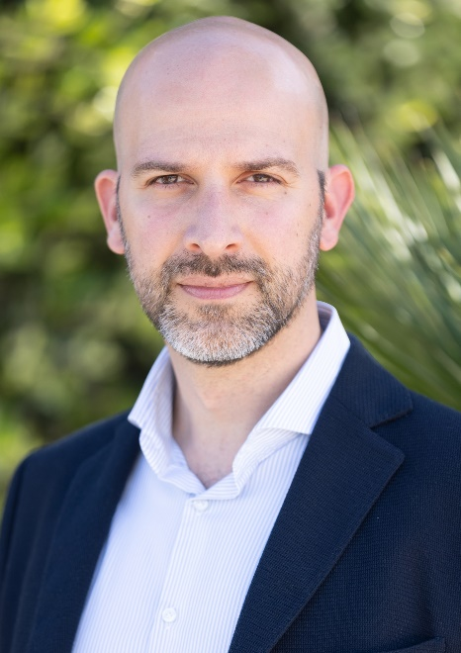
Pietro Russo is Master of Wine, following Gabriele Gorelli and Andrea Lonardi, with whom he shared his studies. The 38-year-old Sicilian oenologist is the third in Italy to have obtained the prestigious title from the Institute of Masters of Wine, the most authoritative and oldest wine organization in the world.
Pietro Russo was born in 1985 in Marsala (Sicily). From a young age, he was able to gain an intimate understanding of the world of wine thanks to his grandfather, a vinefrower, and his father, an agrifood inspector.
After completing his scientific high school diploma, he moved to Conegliano Veneto (Treviso) where he obtained a three-year degree in Oenology and Viticulture. He then moved to Asti for his specialist studies and continued his international education with studies in Montpellier and Bordeaux, where he conducted a thesis on the various terroir of Pomerol.
He had work experiences in Languedoc, Sicily, Spain, Bordeaux, Tuscany and New Zealand. In 2010, he returned to his native land to begin his career as a member of the Donnafugata winemaking team.
"We are delighted with this result achieved by Pietro Russo - comments Vittorio Ruggieri President of Donnafugata -. He is an example of dedication, competence, and passion for the richness and diversity of Sicily, of which our vineyards and wines express the essence well. We have worked together over the years on projects aimed at enhancing and accrediting Sicilian wines worldwide, allowing Pietro to also dedicate himself to his growth path.”

Marsala: February 23, 2024
Donnafugata
Public Relations
Baldo M. Palermo baldo.palermo@donnafugata.it
Emanuele Corsale emanuele.corsale@donnafugata.it

