PRESS RELEASE
Mille e una Notte and Ben Ryé awarded by
"World's Best Sommelier Selection 2024".

The selection of the world's best sommeliers through an unprecedented journey to discover international wine excellences
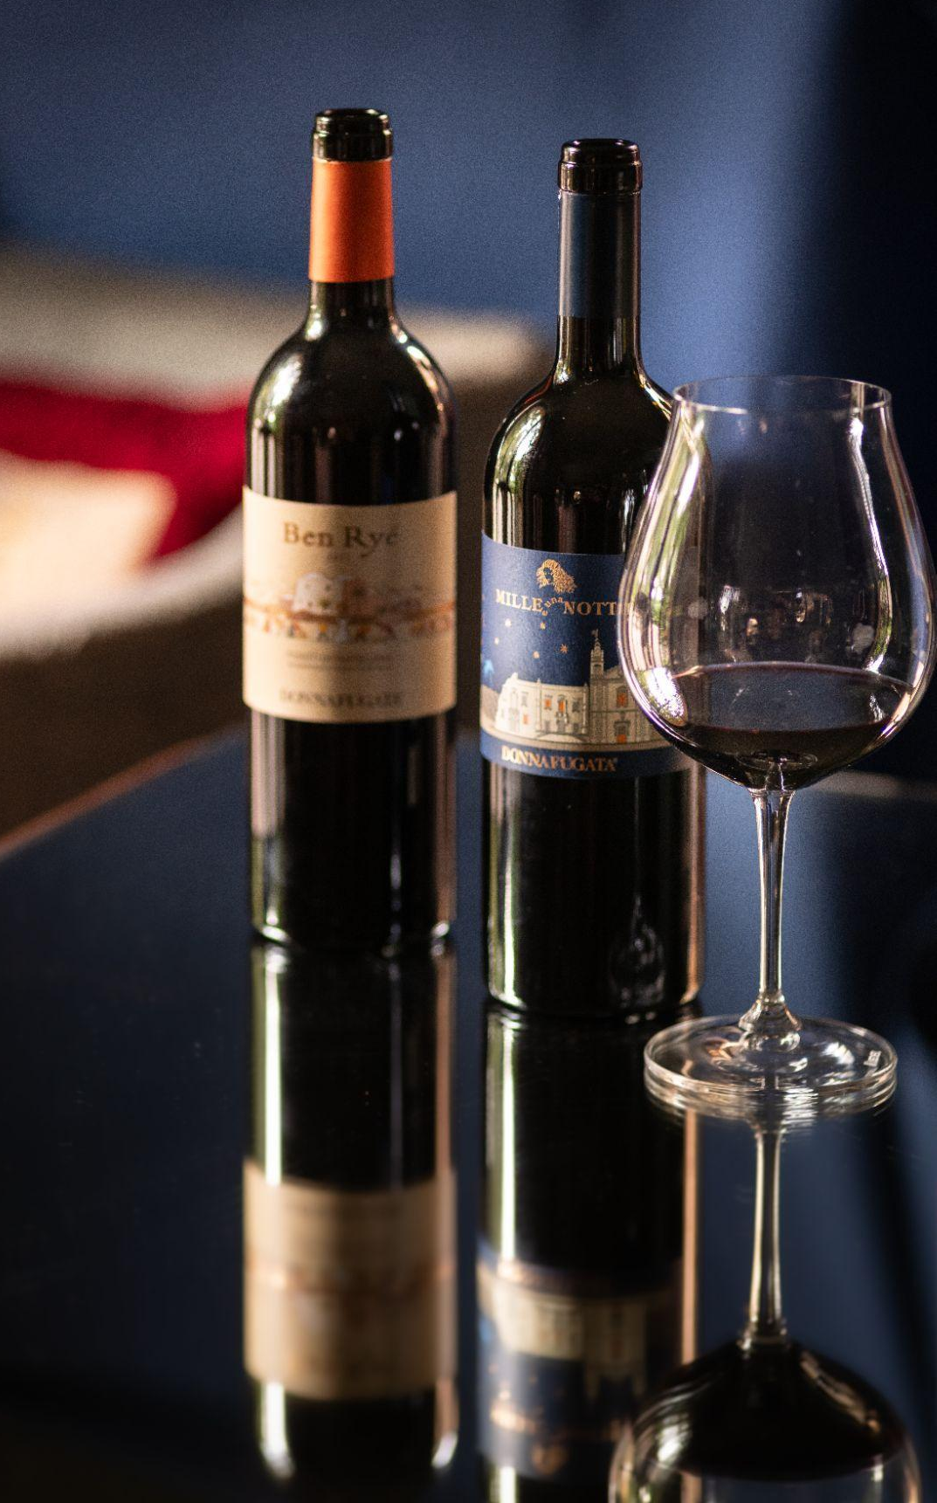
Thirty of the world's most renowned sommeliers, from 4 continents and 16 different countries, gathered in London to taste a selection of great wines together.
The international tasting panel was led by Josep Roca, sommelier at the three-Michelin-starred restaurant 'El Celler de Can Roca'. The world's most refined palates had access to all the information behind each label tasted, and were able to assess the production characteristics, organoleptic profile and history of each wine.
Mille e una Notte and Ben Ryé, Donnafugata's iconic wines, were included in the special and unprecedented "World's Best Sommelier Selection", proving once again that they are able to conquer the most demanding palates and to be ambassadors of Sicily's quality wine around the world.
The jury, composed of the top sommelier part of the "World's 50 Best Restaurants" selected only 130 wines through an unprecedented journey to discover international wine excellences. Each award-winning wine was described in depth and compellingly.

Mille e una Notte 2019 - Sicilia Doc – “An intense Nero d'Avola combined with nuances of Petit Verdot and Syrah, produced from the best grapes of the vintage on the Contessa Entellina hills, initially very fragrant with herbaceous notes, blackcurrant, red pepper, dill, paprika, fennel and ripe plum. A combination as unusual as it is bold”

Ben Ryé 2013 - Passito di Pantelleria Doc - “Mediterranean sunshine in a glass; the rich, ripeness of the fruit is supported by a really nice acidity. The texture is viscous and most pleasant. The notes of toasted walnuts on the nose suggestive of Vin Jaune. The concentration is there, as is the complexity and the length is really persistent. Outstanding.”
Marsala, February 13, 2024

PUBLIC RELATIONS
Baldo M. Palermo baldo.palermo@donnafugata.it tel. 0923 724 226
Emanuele Corsale emanuele.corsale@donnafugata.it tel. 0923 724 225

