PRESS RELEASE
Donnafugata Music & Wine: A Huge Triumph Even in Canada
Josè Rallo has returned to tell the story of Sicilian wine through music; on the stage of The University Club in Toronto, an evening-event to the rhythm of Jazz and Brazilian melodies.
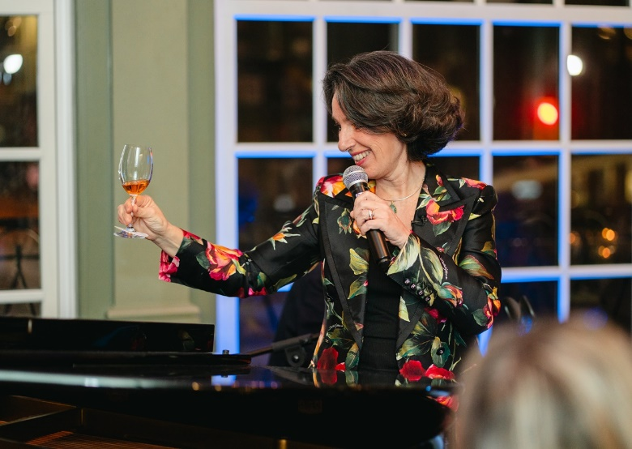
The stars of the evening were wines to be drunk and listened to together with Josè Rallo for Donnafugata: A Feast for the Senses, the latest event of the "Donnafugata Music&Wine" project. The face and voice of the Sicilian company flew to Canada, and yesterday took the stage at The University Club in Toronto for a new musical tasting of small, prestigious productions in front of an audience of enthusiasts and collectors. With her were her husband, Vincenzo Favara, on percussion and Diego Spitaleri, on piano, once again together for a multisensory experience of jazz and Brazilian melodies.
Each wine was accompanied by a song, whose rhythmic progression was supported by tasting sensations: the Donnafugata sparkling wine kicked off the musical stories. In a crescendo of aromas in the historic University Avenue, the classic method gave way to Etna labels, an expression of volcano and mountain viticulture; earthiness and elegance filled the glasses of the diners to the notes of the hypnotic Pelas Tabelas and then of Sicily, a song by Chick Corea that Pino Daniele lovingly dedicated to Sicily.
Instead, the An Older Man is Like an Elegant Wine ballad was the musical background to the tasting of Mille e una Notte, Donnafugata's iconic red. Directly from the hills of Contessa Entellina (western Sicily), some of the best vintages of the historical reserve of a wine distinguished for its extraordinary longevity were featured. The event closed on a sweet note with the passito Ben Ryè, the symbol of the heroic viticulture of Pantelleria, paired with Branquinha, by Caetano Veloso.
“It was a magical evening. - declared the wine entrepreneur Josè Rallo - For emotions, you don't need translations, and music and wine have the extraordinary ability to break down every cultural barrier. Everything becomes universal, and together we shared harmonies and memories. This is a country that has always loved our wine, embraced our way of producing handcrafted wines; being here in Canada was for me a renewed opportunity of encountering wine lovers as well as a personal enrichment for myself.”
The formula has proved to be a winning one, as part of a project that began in 2002 and which to date boasts the production of three albums available on Spotify and the leading streaming platforms. Every art has a language with which it expresses itself, and Music&Wine remains a visionary exchange that promotes wines with a distinct identity, in search of striking images; a quest the company has always championed, starting right from the choice of its name and logo, and then establishing itself with the artistic labels, tributes to literature, and other expressions of unconditional love for Sicily.
Donnafugata: A Feast for the Senses was a special evening promoted by the Canadian Liquor Control Board of Ontario and by Univins, which have recognized Donnafugata Music&Wine as an extraordinary model of communication of Made In Italy wine excellence. Over the years Josè Rallo has, in fact, been the leading voice of other concert-events around the world, and in the wake of this success, she has also performed in Beijing, Shanghai, at the Blue Note in New York and at the Acropolis Museum in Athens.
Marsala, March 22nd, 2024
PUBLIC RELATIONS - Baldo M. Palermo baldo.palermo@donnafugata.it tel. 0923 724 226

