PRESS RELEASE
Fashion and Wine Celebrate "Handcrafted”
Donnafugata at the exhibition “Dal Cuore alle Mani: Dolce&Gabbana” (From the Heart to the Hands: Dolce&Gabbana)
inaugurated at the Palazzo Reale in Milan

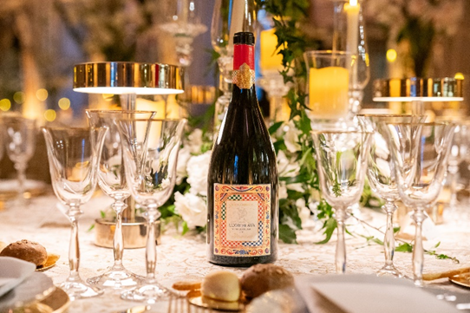
The wines produced from the collaboration between Donnafugata and Dolce&Gabbana participated in the inauguration of the exhibition “From the Heart to the Hands: Dolce&Gabbana”, scheduled at the Palazzo Reale in Milan from 7 April to 31 July: an exhibition which, through their dream of Haute Couture, tells the artistic and creative story of Domenico Dolce and Stefano Gabbana.
On the occasion of the inaugural gala dinner held in the fascinating Sala delle Cariatidi of Palazzo Reale, Donnafugata and Dolce&Gabbana wines celebrated the link that began in 2019 between fashion and wine, creativity and craftsmanship, key elements of the partnership between the Sicilian winery and the famous fashion house.
The exhibition celebrates handmade craftsmanship - a trademark also of Donnafugata's small, prestigious productions, which is how the winery best interprets the ever-changing interaction of specific territories, vines and the climatic trend of each vintage.
From the vineyard to the winery, from the "heart to the hands", the meticulous stages of the "Handmade" process always require sensitivity, expertise and dedication: from pruning to harvesting, from winemaking to ageing.
Today, the Donnafugata and Dolce&Gabbana wine collection is represented in over 60 countries by extraordinary worldwide ambassadors of Sicilian colours, aromas and culture: Rosa, Isolano, Cuordilava and Tancredi, produced at the Contessa Entellina and Etna Estates.
The lines and colours of the sumptuous baroque express the personality of the prestigious Tancredi, while the motifs of the iconic Sicilian cart enhance the identity of the seductive Rosa rosé, the enveloping Isolano white and the elegant Cuordilava red.
One of the ten rooms of the exhibition at Palazzo Reale is devoted precisely to the Carretto (small Sicilian cart) —one of the most significant and most original forms of Sicilian artistic craftsmanship. The exhibition itinerary ends up at the gift shop, where visitors can find unique items created especially for the occasion, the wines of the partnership, and other products that are symbols of a lifestyle resulting from Dolce & Gabbana's creativity.
After Milan, the exhibition “From the Heart to the Hands: Dolce&Gabbana” will be the main event of an international tour that will be visiting some of the world's most important cultural centres.
Marsala, April 2024

PRESS OFFICE - Nando Calaciura calaciura@granviasc.it cell. 338 322 9837
PUBLIC RELATIONS - Baldo M. Palermo baldo.palermo@donnafugata.it tel. 0923 724 226

