PRESS RELEASE
Cantine Aperte, Discovering the World of Donnafugata
On Sunday, May 26, Donnafugata will open its estates to welcome wine lovers on the occasion of Cantine Aperte, the spring event organised by the Wine Tourism Movement.
As tradition dictates, this year Donnafugata will once again be participating in Cantine Aperte, the event organised by the Wine Tourism Movement under the banner of drinking well. From the legendary wineries of Marsala to the estates of Etna and Vittoria, the event is scheduled for Sunday, 26 May, from 11:30 am to 5:30 pm, with an exclusive programme of tours, sophisticated food-and-wine tastings with 0km ingredients and special masterclasses.
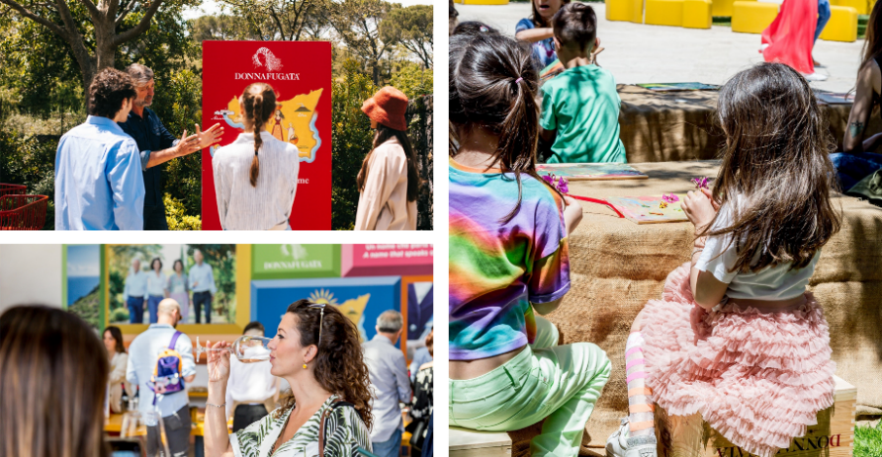
It will be a day of celebration in close contact with nature, an opportunity to give voice to extraordinary productions and good practices in terms of sustainability, in a festive atmosphere animated by music.
The featured stars of this new multisensory journey are some of Donnafugata's most representative labels, including Donnafugata and Dolce & Gabbana Magnum’s delicate rosè Rosa 2023, Vittoria’s elegant Nero d'Avola Contesa dei Venti 2021, the enveloping Etna Bianco Sul Vulcano 2018 Magnum, up to the productions of Pantelleria's heroic viticulture: the sweet Kabir 2022, the iconic Ben Rye 2022, and of course the Lighea.
Produced from Zibibbo grapes, it is an aromatic white which, with the 2023 grape harvest, reiterates the company's commitment to sustainability, adopting the lighter One Hundred per Cent Sicily bottle, produced on the island from glass recycled in Sicily, and the Nomacorc Ocean cork obtained by recycling plastic collected in coastal areas.
Cantine Aperte will be the setting for a selection of wines paired with street food. Tastings and tours will inspire thoughts that wine lovers can then write down on the appropriate totems or share directly on social channels with the @Donnafugatawine and #DonnafugataExperience tags: an engaging moment to make your experience in the world of Donnafugata an unforgettable one.
Between one glass and another, Donnafugata is also offering an unprecedented masterclass, Chiarandà: Large Formats for Great Vintages, dedicated to this chardonnay with incredible longevity, with tastings of the 2007, 2010 and 2021 vintages in Magnum format. Experts and enthusiasts will be able to follow the in-depth session at five different times.
On the Randazzo estate, immersed in the Etna Park, a visit to the vineyard is on offer to discover the mountain viticulture that gives life to wines with a surprising personality. The secrets of the company's unique craftsmanship will also be revealed in Acate, an extraordinary area between the Hyblean plateau and the sea, where red wines with a floral soul originate. Olfactory memories and visual emotions are condensed in the gardens cultivated on both estates, a faithful reflection of the values of environmental sustainability.
At Marsala the tour begins in the legendary family wineries which preserve the typical layout of the Mediterranean farmhouse; finally, an exceptional stop is planned in the splendid underground barrique cellar. At Marsala, the recently inaugurated Wine Museum inside the charming Palazzo Fici in Via XI Maggio 32 (from 10 am to 6 pm) is certainly worth a visit.
Finally, the Contessa Entellina and Pantelleria estates offer an all-around wine experience. The wine tourism season officially opens on the island of the wind.
Everything is ready for an extraordinary day, Donnafugata style. Cantine Aperte and tastings are available online in advance, while places last: https://visit.donnafugata.it/it/cantine-aperte-2024.
Marsala, 20 May 2024
PRESS OFFICE Nando Calaciura calaciura@granviasc.it cell. 338 322 9837
PUBLIC RELATIONS Baldo M. Palermo baldo.palermo@donnafugata.it tel. 0923 724 226

Cantine Aperte at Donnafugata
PROGRAMME
When: Sunday, 26 May, 2024, from 11:30 am to 5:30 pm.
Ticket: €40, online presale, while places last.
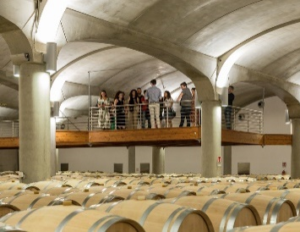
Legendary Wineries at Marsala
The programme begins in Marsala with a visit to the legendary family wineries, which preserve the typical layout of the Mediterranean farmhouse. The tour includes an exceptional stop at the splendid underground barrique cellar.
Local street food will be followed by a walk-around tasting of a special selection of wines: Rosa 2023 Magnum, Vigna di Gabri 2022, Lighea 2023 Zibibbo, Contesa dei Venti 2021 Nero d'Avola, Marchesa 2018 Magnum Etna Rosso, Tancredi 2017 Magnum, Kabir 2022 Moscato di Pantelleria, Ben Ryè 2022 Passito di Pantelleria.

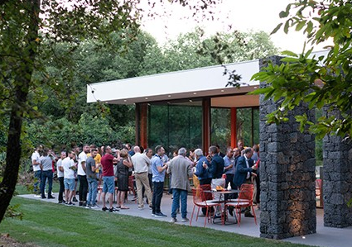
Etna Estate
At the Randazzo Estate, immersed in the fabulous Etna Park, the programme begins with a visit to the vineyard, where you can discover good practices for environmental sustainability. There will be a presentation of the mountain viticulture that gives life to wines with a unique personality. The walk will also stop in a portion of the woods with an awe-inspiring wealth of wild herbs, finally arriving at the winery to discover the secrets of winemaking.
Local street food will be followed by a walk-around tasting of a special selection of wines: Rosa 2023 Magnum, Sul Vulcano 2018 Magnum Etna Bianco, Lighea 2023 Zibibbo, Contesa dei Venti 2021 Nero 'Avola di Vittoria, Sul Vulcano 2021 Etna Rosso, Marchesa 2018 Magnum Etna Rosso, Kabir 2022 Moscato di Pantelleria, Ben Ryè 2022 Passito di Pantelleria.
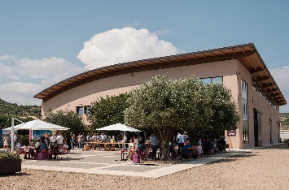
Vittoria Estate
At Vittoria Estate, in Acate, the programme begins with a visit to the vineyard, where you can discover good practices for environmental sustainability. There will be a presentation of the viticulture of this splendid area, between the Hyblean plateau and the sea, which gives life to wines with a distinctive floral personality. After the stop at the "verziere" (vegetable garden) with its tubs of Sicilian aromatic herbs, the visit comes to an end in the futuristic winery, to discover the secrets of winemaking.
Local street food will be followed by a walk-around tasting of a special selection of wines: Rosa 2023 Magnum, Sul Vulcano 2018 Magnum Etna Bianco, Lighea 2023 Zibibbo, Bell'Assai 2022 Frappato di Vittoria, Floramundi 2022 Cerasuolo di Vittoria, Contesa dei Venti 2021 Nero 'Avola di Vittoria, Kabir 2022 Moscato di Pantelleria, Ben Ryè 2022 Passito di Pantelleria.
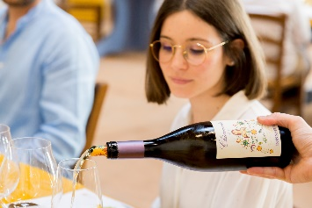
Marsala—Etna—Vittoria: Already included in the price, you can book—directly at the winery—participation in the "Chiarandà: Large Formats for Great Vintages" masterclass, which includes the tasting of the 2007, 2010 and 2021 vintages of Chiarandà magnum. It will be held at the following times: 12:30 pm, 1:30 pm, 2:30 pm, 3:30 pm, and 4:30 pm.
As always, the atmosphere of Cantine Aperte will be festive, animated by music and fun even for families with children, thanks to special entertainment for the little ones.
On Sunday, 26 May, the Contessa Entellina Estate and Pantelleria Estate will also be open to the public for visits, tastings, and sophisticated food-and-wine pairings.

