For immediate release
Josè Rallo among the Winners of the 2024 Women in Wine & Spirits Awards (WINWSA): An achievement for Female leadership in the Global Wine Industry
Marsala, November 25, 2024 – Josè Rallo, a prominent figure in the wine world and CEO of Donnafugata, has been named among the Top 50 prizewinners of the prestigious Women in Wine & Spirits Awards (WINWSA) 2024. She earned recognition in the Vision Award for Sustainability category, a tribute to her contributions to innovation and sustainability in the Wine&Spirits sector. An international accolade highlighting excellence among women in the Wine & Spirits industry, celebrating their impact on the future of the field.
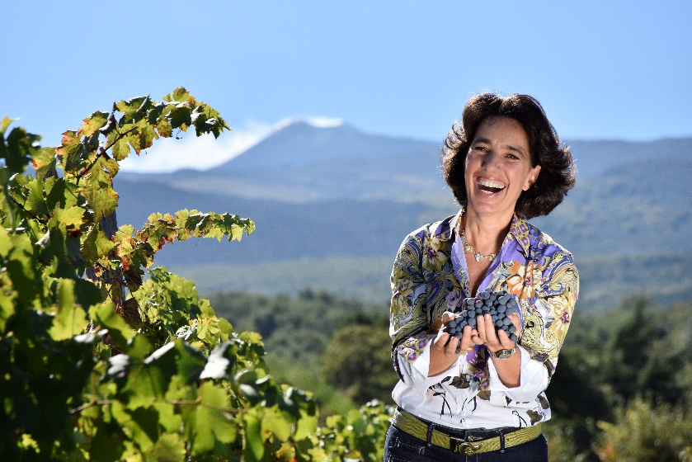
"This award is a milestone and a booster," José Rallo commented. "It reflects our dedication to creating a more sustainable future while honoring the strategic role of Wine Industry in preserving the ecosystem. I’m deeply honored to represent women in both the Italian and global wine industries and to stand alongside an extraordinary group of professionals committed to innovation and sustainability."
In the Vision Award for Sustainability category, Rallo was joined by Kristin Belair, Director of Winegrowing & Sustainability at California’s Honig Vineyard and Winery, emphasizing the shared global commitment to sustainable practices.
The 2024 WINWSA recognized winners from 26 countries and regions across 17 categories spanning production, services, marketing, and education in the Wine & Spirits sector. Hundreds of nominations and applications were submitted from regions including China, Asia-Pacific, Africa, the Americas, and Europe, showcasing the diverse and innovative contributions of women globally.
Italy boasts seven winners, nominated by the National Association of Women in Wine (Donne del Vino), whose National President, Daniela Mastroberardino, served as a juror.
The WINWSA continues to establish itself as a trailblazing initiative, not only celebrating female excellence but paving the way for future generations of women in Wine & Spirits.
To view the list of 50 winners: http://www.winwsa.com/news/news20241115/
About The Women in Wine & Spirits Awards: WINWSA now in its fifth year, was founded in January 2020 by Michelle Liu, a wine journalist and marketing consultant. The awards aim to recognize, connect, and celebrate women professionals redefining industry standards worldwide, promoting leadership, innovation, and sustainability.
PUBLIC RELATIONS
Laura Bertoni
laura.bertoni@donnafugata.it
mob. +39 346 5031515

